Table Of Content
Chapter | Section | Title
1 | 1.0 | Introduction
 | 1.1 | Background of the Study
 | 1.2 | Problem Statement
 | 1.3 | Objectives of the Project
 | 1.4 | Scope of the Project
2 | 2.0 | Literature Review
 | 2.1 | Overview of Online Hotel Booking Systems
 | 2.2 | Study of Existing Systems
 | 2.3 | Comparison of Existing Systems
 | 2.4 | Stakeholder Identification and Analysis
 | 2.5 | Primary and Secondary Users
 | 2.6 | Technology Review
 | 2.7 | Research Gap
3 | 3.0 | System Analysis
 | 3.1 | Existing System Analysis
 | 3.2 | Limitations of Existing System
 | 3.3 | Proposed System
 | 3.4 | Feasibility Study
 | 3.4.1 | Technical Feasibility
 | 3.4.2 | Operational Feasibility
 | 3.4.3 | Economic Feasibility
 | 3.4.4 | Schedule Feasibility
 | 3.5 | Requirement Analysis
 | 3.5.1 | Functional Requirements
 | 3.5.2 | Non-Functional Requirements
 | 3.6 | Use Case Analysis
 | 3.7 | Data Flow Diagram
4 | 4.0 | System Design
 | 4.1 | System Architecture
 | 4.2 | Database Design
 | 4.3 | Entity Relationship Diagram
 | 4.4 | Class Diagram
 | 4.5 | Sequence Diagrams
 | 4.6 | Component Diagram
 | 4.7 | Deployment Diagram
 | 4.8 | User Interface Design
 | 4.9 | Project Timeline
5 | 5.0 | Implementation
 | 5.1 | Technology Stack
 | 5.2 | Development Environment Setup
 | 5.3 | Module Implementation
 | 5.3.1 | Authentication Module
 | 5.3.2 | Room Catalog Module
 | 5.3.3 | Booking Module
 | 5.3.4 | Payment Simulation Module
 | 5.3.5 | Admin Dashboard Module
 | 5.3.6 | Reporting Module
 | 5.4 | Source Code Repository
 | 5.5 | API Documentation
 | 5.6 | Database Implementation
6 | 6.0 | Testing
 | 6.1 | Testing Strategy
 | 6.2 | Test Cases
 | 6.3 | Test Results
 | 6.4 | User Acceptance Testing
7 | 7.0 | Results and Discussion
 | 7.1 | System Features Achieved
 | 7.2 | Performance Evalution
 | 7.3 | User Experience Evalution
8 | 8.0 | Conclusion and Future Scope
 | 8.1 | Project Summary
 | 8.2 | Achievements
 | 8.3 | Limitations
 | 8.4 | Future Scope
9 | 9.0 | References
10 | 10.0 | Appendices
 | 10.1 | Screenshots
 | 10.2 | Source code snippets
 | 10.3 | User Manual

CHAPTER 1: INTRODUCTION
1.1 Background of the Hospitality Industry
- The hospitality industry has undergone a significant digital transformation in recent years, with travelers increasingly preferring online platforms for hotel reservations over traditional booking methods such as phone calls or walk-in inquiries. However, many small to medium-sized hotels still struggle with outdated booking systems that lack user-friendly interfaces, real-time availability updates, and efficient management capabilities. This digital gap results in lost revenue opportunities, double bookings, poor customer experience, and administrative inefficiencies.

- The current market solutions like Booking.com, Expedia, and MakeMyTrip, while comprehensive, often charge substantial commission fees (15-25%) and may not cater specifically to the needs of independent hotels or regional hotel chains. There exists a need for a lightweight, customizable, and cost-effective hotel booking solution that provides essential functionalities without the overhead of enterprise-level systems. This project aims to develop a responsive, modern web-based hotel booking application using React JS that enables guests to search, view, and book hotel rooms seamlessly while providing hotel administrators with tools to manage rooms, bookings, and basic analytics.

1.2 Problem Statement
- Traditional and semi-digital hotel booking systems often suffer from significant inefficiencies. Many existing systems lack a cohesive, responsive user interface, making mobile browsing difficult and leading to customer attrition. Furthermore, reliance on outdated server-side rendered pages can lead to sluggish performance during peak booking times.

- From an administrative perspective, hotel managers face challenges in keeping track of real-time inventory, handling booking cancellations equitably, and producing insightful analytical reports. Fragmented systems often result in data redundancy and security vulnerabilities. Therefore, the core problem is the absence of an integrated, highly responsive, and robust platform that bridges the gap between eager customers seeking seamless booking experiences and administrators requiring efficient, automated management tools.

- StayEase aims to solve this by developing a centralized, real-time hotel booking application that eliminates intermediary fees, ensures data integrity, and provides a fluid, real-time interface using React JS.

1.3 Objectives
- The primary objective of the StayEase project is to design, develop, and deploy a comprehensive Web-based Hotel Booking System. The objectives are defined using the SMART framework (Specific, Measurable, Achievable, Relevant, and Time-bound):

- Specific: To build a full-stack web application with distinct portals for Guests (for searching and booking rooms) and Administrators (for managing rooms, bookings, and generating reports).
- Measurable: The system must successfully handle standard operational flows encompassing user registration, room catalog rendering, booking confirmations, and admin dashboard analytics without functional errors, with an average page load time of under 2 seconds.
- Achievable: Utilizing popular MERN (MongoDB/MySQL, Express, React, Node.js) technologies to ensure standard industry practices are followed, making the project viable within the academic timeframe.
- Relevant: The application addresses a genuine need in the hospitality tech sector, providing a tangible solution for inventory and reservation management.
- Time-bound: To complete the requirements gathering, system design, implementation, and rigorous testing phases within the allocated final-year project semester timeline.

1.4 Scope of the Project
What is Included:
- Guest-facing hotel room search and booking interface
- User registration and authentication system
- Room listing with details, images, and pricing
- Date-based availability checking Booking creation, viewing, and cancellation (by user)
- Admin panel for room and booking management
- Basic booking reports and statistics
- Responsive web design for multiple devices
- Mock payment integration (simulation)
- Email notification simulation (console/mock)
What is Clearly Excluded:
- Real payment gateway integration (Stripe, PayPal, etc.)
- Actual email/SMS notification services
- Mobile native applications (iOS/Android)
- Multi-hotel/chain management
- Advanced revenue management and dynamic pricing
- Third-party OTA (Online Travel Agency) integrations
- Loyalty programs and reward points
- Multi-language and multi-currency support
- Real-time chat support
- Integration with property management systems (PMS)

1.5 Organization of the Report
- The subsequent chapters of this document are structured as follows:
- Chapter 2 (Literature Review): Reviews existing solutions, compares them with StayEase, and justifies the chosen technology stack.
- Chapter 3 (System Analysis): Details the existing systems, proposed solutions, feasibility studies, and comprehensive requirement specifications.
- Chapter 4 (System Design): Provides in-depth architectural and structural designs, including DFDs, ER diagrams, and UML diagrams (Use Case, Class, Sequence, Component, Deployment).
- Chapter 5 (Implementation): Covers the technology stack, environment setup, module development strategies, and API documentation.
- Chapter 6 (Testing): Discusses the testing methodologies, executes a suite of test cases, and outlines the system's operational stability.
- Chapter 7 (Conclusion and Future Scope): Summarizes the project's achievements, acknowledges its limitations, and maps out potential future enhancements.

CHAPTER 2: LITERATURE REVIEW
2.1 Existing Hotel Booking Systems
The evolution of e-commerce has led to a saturated market of Online Travel Agencies (OTAs). Conducting a literature review requires analysing the predominant market leaders to identify standard features, operational paradigms, and areas for potential innovation.

- 2.1.1 Booking.com
- Booking.com is one of the largest travel e-commerce companies globally. It offers an aggregator platform where users can book hotels, flights, and car rentals. It is highly optimized for SEO and conversion, featuring dynamic pricing and extensive user reviews. However, the system is exceptionally heavy and can be overwhelming due to aggressive marketing tactics (e.g., "Only 1 room left" notifications).

- 2.1.2 MakeMyTrip
- Focused primarily on the Indian demographic, MakeMyTrip provides comprehensive travel packages. Its interface integrates multiple transport booking systems alongside hotels. The platform is robust but its hotel management portal for property owners often receives criticism for complex commission structures and delayed payout models.

- 2.1.3 OYO Rooms
- OYO disrupted the hospitality sector by standardizing budget hotels. Instead of merely being an aggregator, OYO franchises properties and ensures basic amenities. The OYO app is minimalist and highly responsive, tailored for budget-conscious and frequent travellers. A persistent disadvantage has been quality control inconsistencies across different geographically dispersed properties.

- 2.1.4 Airbnb
- Airbnb pioneered the homestay and peer-to-peer lodging sector. Its platform emphasizes community, unique experiences, and a highly visual, map-based search interface. The architecture is renowned for its scalability and modern UI components. However, its pricing structure (inclusive of cleaning and service fees) frequently obscures the base rate for users.

2.2 Comparison of Existing Systems
- Many online platforms are available for hotel and accommodation booking. Popular platforms such as Booking.com, MakeMyTrip, OYO, and Airbnb provide different services to users. Studying these systems helps to understand their strengths and weaknesses and also helps in designing the proposed StayEase system.
- Booking.com is a global hotel booking platform that works as an aggregator. It connects users with a large number of hotels around the world and provides verified reviews from travellers. However, the platform charges high commission fees to hotels and sometimes its interface contains too much information, which may confuse users.
- MakeMyTrip is a well-known travel platform in India that provides services such as hotel booking, flight booking, and travel packages. It supports various local payment methods and is widely used by Indian travellers. However, because it provides many services on a single platform, the interface can appear complex and cluttered for users.
- OYO mainly focuses on budget-friendly hotels and standardized rooms. The platform allows users to book rooms quickly using a simple and mobile-friendly interface. OYO follows a revenue-sharing model with hotels. However, the quality of rooms and services may sometimes vary between different properties.
- Airbnb provides unique accommodation options such as homestays, apartments, and shared spaces. It offers a visually attractive interface with map-based search features. Although it provides unique travel experiences, users may face additional service fees, and in some locations the platform faces regulatory issues.
- The proposed system, StayEase, focuses on direct hotel booking through a simple and efficient platform. It aims to provide a clean and responsive user interface that allows users to easily search, view, and book rooms. Unlike other platforms, StayEase does not charge middleman commission fees, which benefits both hotels and customers. Although the platform may initially have fewer listed properties, it focuses on providing a fast, lightweight, and user-friendly booking experience.

2.4 Stakeholder Identification and Analysis
Stakeholder | Role | Responsibilities | Expectations from system
Project Guide/Supervisor | Academic Mentor | Provide guidance, review progress, evaluate project, approve deliverables | Well-documented code, proper methodology, regular progress updates, demonstration readiness
Student Developer | Development Team | Design, develop, test, document the entire application; meet deadlines | Clear requirements, realistic scope, learning opportunity, portfolio worthy project
End Users (Guests) | Primary Users | Search hotels, make bookings, manage reservations | Easy-to-use interface, fast response, reliable booking confirmation, mobile-friendly
Hotel Administrator | Admin User | Manage rooms, handle bookings, view reports, update availability | Efficient dashboard, quick operations, accurate data, minimal training required
External API Providers | Technical Dependency | Provide image hosting, mock payment, authentication services | Reliable uptime, clear documentation, free tier availability
Examination Committee | Evaluators | Assess project quality, innovation, implementation, documentation | Complete functionality, proper testing, good presentation, technical depth

2.5 Primary and Secondary Users
Primary Users:
- Hotel Guests - Individuals seeking to book hotel accommodations online
- Hotel Administrators - Staff responsible for managing hotel inventory and bookings.

Secondary Users:
- Project Evaluators/Examiners - Academic staff evaluating the project
- Future Developers - Students or developers who may extend this project
- Hotel Owners - Business stakeholders interested in booking statistics (view-only)

    - User Personas
Persona 1: Priya Sharma (Guest User)

Attribute | Details
Name | Priya Sharma
Age | 28 years
Occupation | Marketing Manager at a Tech Startup
Location | Bangalore, Indias
Tech Proficiency | High - uses multiple apps daily
Goals | Find affordable, clean hotels quickly; book without lengthy processes; get instant confirmation; compare room options easily
Frustrations | Slow-loading websites; hidden charges appearing at checkout; complicated registration forms; no mobile-friendly design; unclear cancellation policies
Usage Scenario | Priya is planning a weekend trip and wants to quickly find and book a hotel room from her phone during lunch break. She prefers seeing room photos, reading amenities clearly, and completing booking in under 5 minutes.
Quote | "I don't want to spend 30 minutes just to book a hotel room. Show me what's available and let me book instantly."

Persona 2: Rajesh Kumar (Hotel Administrator)
Attribute | Details
Name | Rajesh Kumar
Age | 42 years
Occupation | Front Desk Manager at Hotel Sunrise
Location | Jaipur, India
Tech Proficiency | Moderate - comfortable with basic computer operations
Goals | View all bookings at a glance; update room availability easily; avoid double bookings; generate daily/weekly reports; quickly add or modify room details
Frustrations | Complex systems requiring extensive training; frequent system crashes; inability to quickly check availability; manual work for report generation
Usage Scenario | Rajesh starts his shift by checking today's arrivals and departures on the admin dashboard. He needs to block a room for maintenance, confirm a VIP booking, and print the weekly occupancy report for the manager.
Quote | "I need a simple system that shows me everything on one screen. I don't have time to navigate through 10 menus.

Persona 3: Amit Verma (Budget Traveler - Guest)
Attribute | Details
Name | Amit Verma
Age | 22 years
Occupation | Final Year Engineering Student
Location | Delhi, India
Tech Proficiency | Very High - tech-savvy, prefers mobile
Goals | Find cheapest available options; filter by price; see student-friendly accommodations; easy cancellation if plans change
Frustrations | Expensive options shown first; mandatory account creation for viewing prices; poor search filters; no price sorting
Usage Scenario | Amit is planning a trip with college friends and needs to find the most affordable room that can accommodate the group. He wants to filter by price, see total cost upfront, and have flexibility to cancel if friends back out.
Quote | "Just show me the cheapest option that doesn't look sketchy. I'll book if I can cancel later.

2.5 Justification of Technology Stack
- For the StayEase application, a modern JavaScript-centric stack was selected based on extensive technical evaluations.
- React JS (Frontend): React is a declarative, efficient, and flexible JavaScript library for building user interfaces. It enables the creation of reusable UI components and manages the dynamic rendering of the DOM flawlessly. Compared to traditional template engines, Reacts Virtual DOM ensures that only the necessary components are updated, resulting in high-speed, interactive user experiences critical for modern booking platforms.
- Node.js & Express (Backend): Node.js allows for JavaScript execution on the server-side, enabling a unified language across the entire application stack. Its non-blocking, event-driven architecture makes it exceptionally well-suited for handling concurrent data-intensive requests, such as searching through a database of available rooms. Express.js is a minimal framework that accelerates REST API development via structured routing and middleware generation.
- REST API: Representational State Transfer (REST) protocols were chosen to decouple the frontend from the backend. This allows for agnostic client connections, meaning mobile apps could theoretically consume the same endpoints in the future without backend restructuring.
- JWT (JSON Web Tokens) Authentication: JWT provides a robust, stateless security mechanism. Rather than maintaining session states on the server, JWTs are issued to authenticated users and validated on subsequent requests, drastically reducing server overhead and facilitating horizontal scalability.
- MongoDB / MySQL (Database): Depending on deployment specifications, MongoDB offers a flexible, schema-less document storage mechanism ideal for rapid prototyping and hierarchical data (like complex Room or Amenities arrays). Alternatively, MySQL provides rigid ACID compliance via relational tables, suitable for strict transaction processing mandated in booking systems.

2.6 Academic Research References
- Buhalis, D., & Law, R. (2008): Progress in information technology and tourism management: 20 years on and 10 years after the Internet—The state of e-Tourism research. Tourism Management, 29(4), 609-623. Provides a foundational overview of the internet's impact on travel intermediaries.
- Law, R., Leung, R., & Wong, J. (2004): The impact of the Internet on travel agencies. International Journal of Contemporary Hospitality Management. Discusses the transition from manual bookings to direct online booking mechanisms.
- Madan, A., & Gupta, P. (2020): A study of user experience (UX) and its impact on customer satisfaction in online hotel booking portals. Journal of Hospitality and Tourism Technology. Highlights the critical role of responsive interfaces, justifying the use of modern libraries like React JS.
- Alotaibi, S., & Mehmood, R. (2017): A comparative study of database models for web-based booking systems. IEEE Computer Society. Discusses the trade-offs between NoSQL and relational structures in handling reservation data synchronization.
- Smith, J. (2021): Stateless Authentication in Microservices: Exploring JWT implementations. Journal of Web Engineering. Outlines the security benefits of using JSON Web Tokens in decoupled architectures.

CHAPTER 3: SYSTEM ANALYSIS
3.1 Existing System
- The traditional methodology for hotel reservations relies heavily on direct customer interaction, manual ledgers, or fragmented digital systems that do not offer real-time synchronization. Customers typically discover hotels through travel agents, print advertisements, or rudimentary websites that act merely as digital brochures.

- To book a room, individuals are required to call the hotel reception or send an email inquiry. The receptionist then manually cross-references the requested dates against a physical reservation book or a standalone, local database application. Financial transactions are often processed via phone (by sharing credit card details) or settled physically upon arrival. This manual data entry process is prone to human error, resulting in overbookings, lost reservations, and dissatisfied customers.
3.2 Problems in Existing System
- The manual and semi-automated existing systems present several critical challenges:
- Time-Consuming Process: Guests spend considerable time researching, comparing prices manually, calling hotels directly, and waiting for availability confirmations.
- Data Inconsistencies: The reliance on verbal communication and manual entry often leads to data duplication or inaccurate reservation logging. Dual bookings for a single room are a common operational hazard.
- Limited Accessibility: Traditional systems require guests to contact the hotel during specific business hours, lacking the 24/7 convenience of cloud-based platforms.
- Lack of Transparency: Customers cannot independently verify room features, view extensive photo galleries, or read authentic reviews before committing.
- Inefficient Management: Hotel administrators lack centralized dashboards to instantly view total occupancy, impending check-ins/check-outs, and revenue metrics.
- Security Risks: Storing customer information, including sensitive payment details locally on unencrypted physical or digital ledgers poses significant security risks.
3.3 Proposed System
- The "StayEase" proposed system is a fully integrated, web-based hotel booking application designed to supersede the limitations of the existing manual processes. Built on a modern tech stack (React JS, Node.js, Express, and a robust Database), it offers a seamless, automated, and secure reservation lifecycle.
- Key functionalities of the proposed system include:

- Real-Time Inventory Synchronization: The system automatically locks and updates room availability the moment a booking is initiated and confirmed, completely eliminating double-booking scenarios.
- Guest Autonomy: Users can autonomously register, browse comprehensive catalogs of rooms with high-resolution images and detailed amenity lists, and finalize bookings through an intuitive interface available 24/7.
- Centralized Admin Dashboard: Administrators are empowered with a secure portal to perform Create, Read, Update, and Delete (CRUD) operations on the room inventory. The dashboard also aggregates booking data, provides statistical insights, and allows for efficient management of user accounts.
- Secure Authentication: Implementing Role-Based Access Control (RBAC) via JSON Web Tokens ensures that sensitive administrative endpoints are strictly protected from unauthorized access.

3.4 Feasibility Study
Before full-scale implementation, a feasibility analysis determines the viability of the StayEase project across multiple dimensions:

3.4.1 Technical Feasibility
The project is technically feasible. The selected MERN-stack technologies are industry standards, well-documented, and supported by massive open-source communities. React JS provides the necessary component-based architecture for building fluid UIs, while Node.js effectively handles the API traffic. No bespoke hardware is required, the application can be hosted on standard cloud infrastructure (e.g., AWS, Heroku, or Vercel).
3.4.2 Operational Feasibility
Operationally, the system directly addresses the inefficiencies of current hotel management practices. The interface is designed to emulate standard web norms, ensuring a minimal learning curve for both guests and administrative personnel. The transition from manual ledgers to a digital dashboard is fundamentally sound and highly anticipated in modern business environments.
3.4.3 Economic Feasibility
The application relies heavily on open-source libraries and frameworks, mitigating upfront software licensing costs. While deployment and database hosting (e.g., MongoDB Atlas) incur marginal costs, the significant reduction in administrative overhead, elimination of intermediary OTA commissions, and potential for increased direct bookings present a compelling return on investment.
3.4.4 Schedule Feasibility
The project architecture was meticulously scoped to align with the time constraints of a final-year academic semester. Utilizing frameworks like Express.js and UI libraries (e.g., Bootstrap/Tailwind) drastically reduces development overhead. Parallel development of the REST API and the React frontend ensures the system can be delivered within the stipulated timeframe.

3.5 Requirement Analysis
- Functional Requirements
- The functional requirements describe the key operations and services that the StayEase hotel booking system must provide to users and administrators. These requirements define how the system should behave and what functionalities must be implemented.
- FR-01 – User Registration:
The system must allow guests to create an account by providing their email address, password, and contact details. This functionality enables new users to register and access the booking services of the platform.
- FR-02 – Authentication:
The system must authenticate users, including both guests and administrators, by validating their login credentials. Upon successful authentication, the system should generate secure session tokens (JWT) to maintain a secure and authorized user session.
- FR-03 – Search and Filter:
The system must allow guests to browse the list of available rooms and provide filtering options based on parameters such as booking date, price range, and room type. This functionality helps users easily find rooms that match their preferences.
- FR-04 – Room Details:
The system must display detailed information about each room, including images, room description, capacity, and available amenities. This allows guests to review the room specifications before making a reservation.
- FR-05 – Booking Management:
The system must enable guests to initiate new room reservations, view their existing bookings, and cancel reservations when required. This functionality provides users with complete control over their booking activities.
- FR-06 – Admin Room Management (CRUD):
The system must allow administrators to manage room records through Create, Read, Update, and Delete (CRUD) operations. Administrators should be able to add new rooms, modify existing room details, and remove rooms from the system.
- FR-07 – Admin Booking Management:
The system must allow administrators to view and monitor all bookings made within the platform. Administrators should be able to access booking details, including booking status and associated user information.
- FR-08 – Dashboard Reporting:
The system must provide an administrative dashboard that generates summary reports containing key system statistics such as total bookings, total revenue, and the number of registered users.

- Non-Functional Requirements
- Non-functional requirements describe the quality attributes and performance standards that the StayEase hotel booking system must meet. These requirements focus on aspects such as system performance, usability, security, reliability, and scalability to ensure that the application operates efficiently and provides a high-quality user experience.
- NFR-01 – Performance:
The system must provide fast response times and ensure that the application loads within two seconds under normal network conditions. This requirement ensures that users can browse rooms and perform booking operations without experiencing delays.
- NFR-02 – Usability:
The system must provide a user-friendly interface that is mobile-responsive and compatible with different screen sizes. Additionally, the interface should follow standard web accessibility guidelines to ensure that all users can easily navigate and interact with the platform.
- NFR-03 – Security:
The system must ensure the protection of sensitive user data by implementing secure authentication mechanisms. User passwords must be encrypted using bcrypt hashing, and all API endpoints must be protected against malicious inputs and potential security threats.
- NFR-04 – Reliability:
The system must maintain consistent operation with minimal downtime. It should be capable of handling multiple users and concurrent booking requests without system failures or data inconsistencies.
- NFR-05 – Scalability:
The system architecture must be designed to support future enhancements, such as integration with online payment gateways, third-party services, or additional modules without significant changes to the existing infrastructure.

3.6 Use Case Diagram
- The Use Case diagram visually models the dynamic interactions between the system's primary actors (Guest and Admin) and the application's core functional milestones.
Actors:
- Guest: A registered or non-registered user interacting with the platform to find and secure accommodation.
- Admin: An authorized system operator responsible for maintaining the application's data integrity and operational oversight.
Use Cases:
- Register/Login: Both actors initiate sessions and secure access levels based on credentials.
- Search / View Rooms: Guests browse the catalog to inspect room features.
- Book Room / Cancel Booking: Guests execute transactions governing their prospective stay.
- Manage Rooms: Admins control the inventory catalog.
- Manage Bookings: Admins oversee the lifecycle of all reservations.
- Generate Reports: Admins extract analytical data.

- Authentication Module
- Actor: Guest, Admin

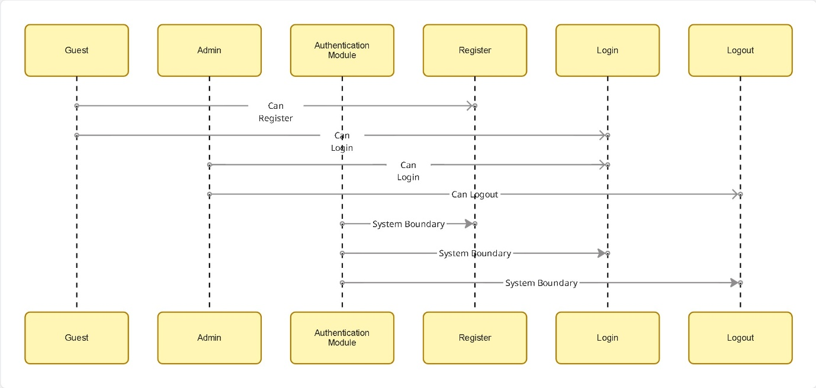

- Room Module
- Actor: Guest, Admin

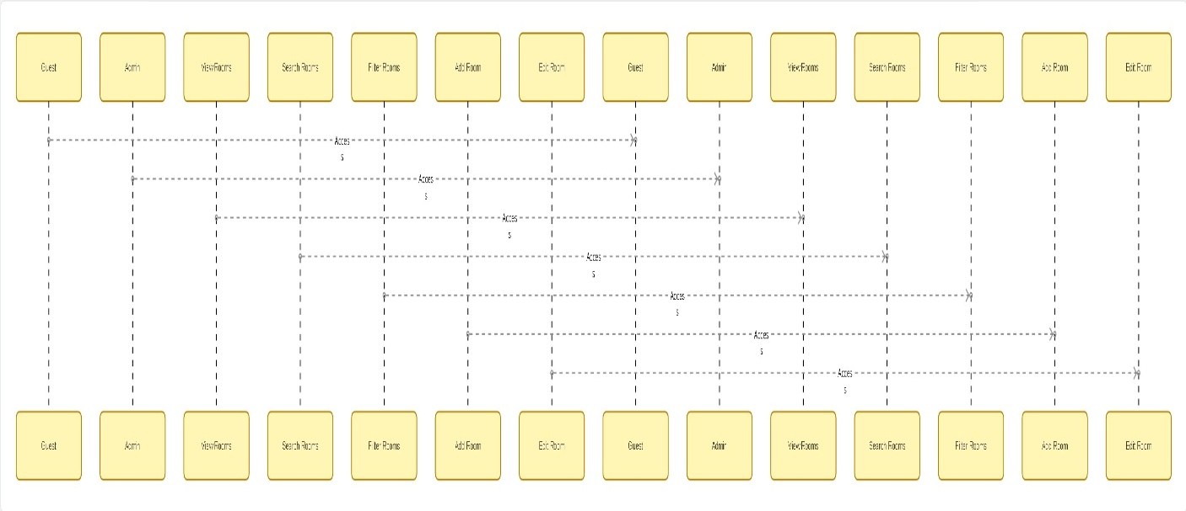

- Booking Module
- Actor: Guest, Admin

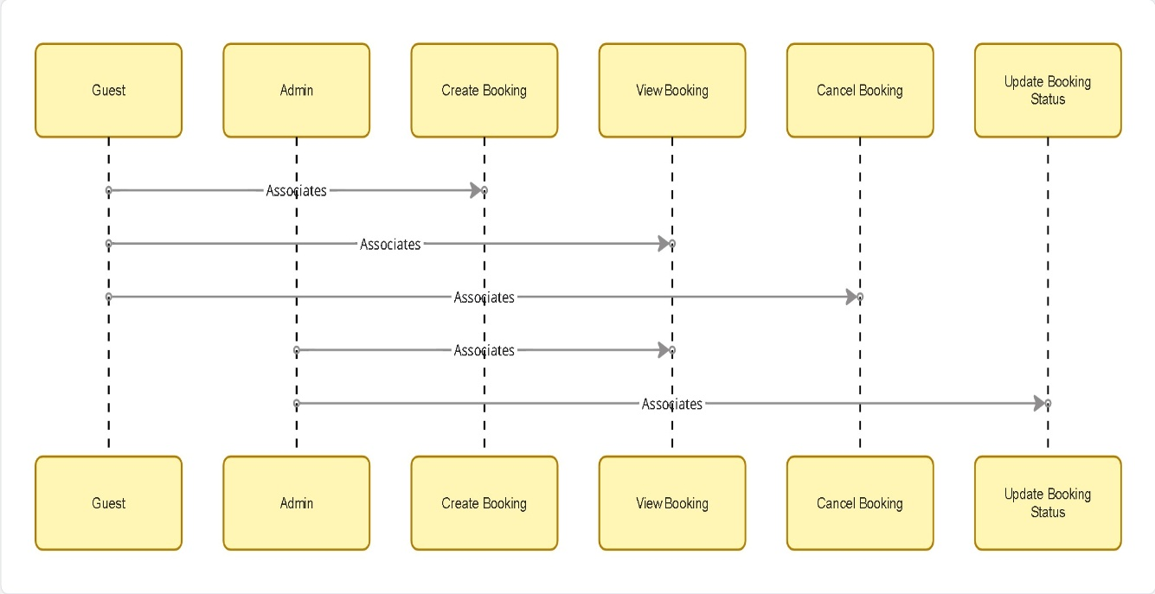

- Payment Module
- Actor: Guest
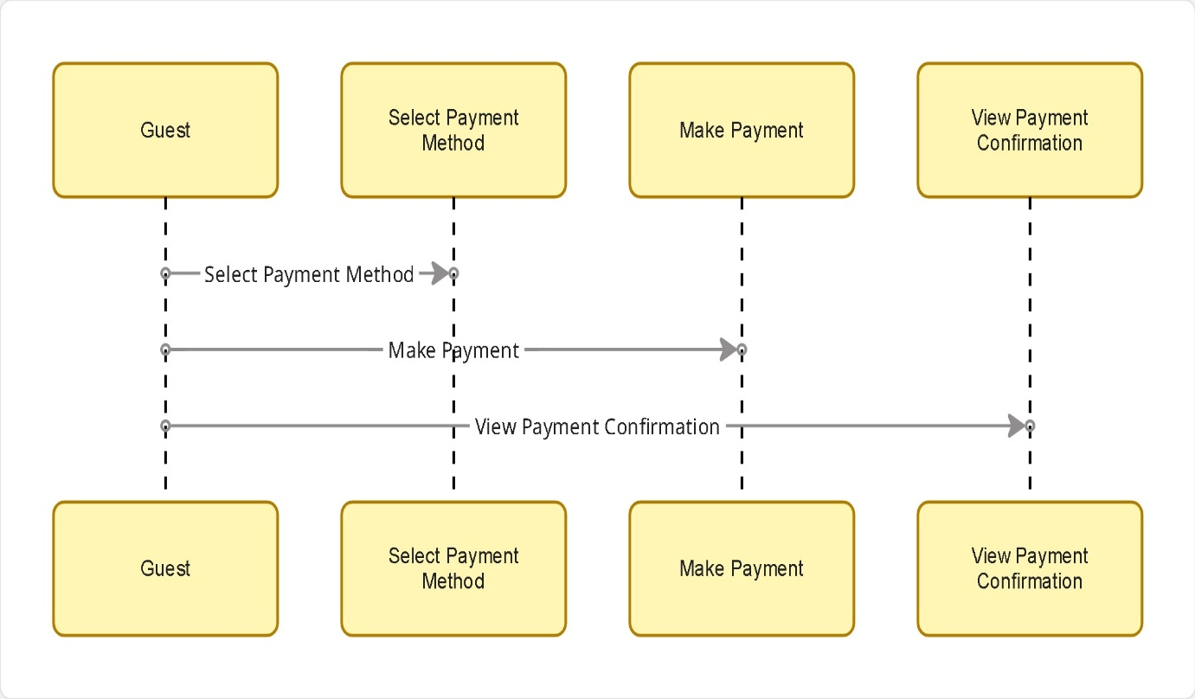

- Profile Module
- Actor: Guest

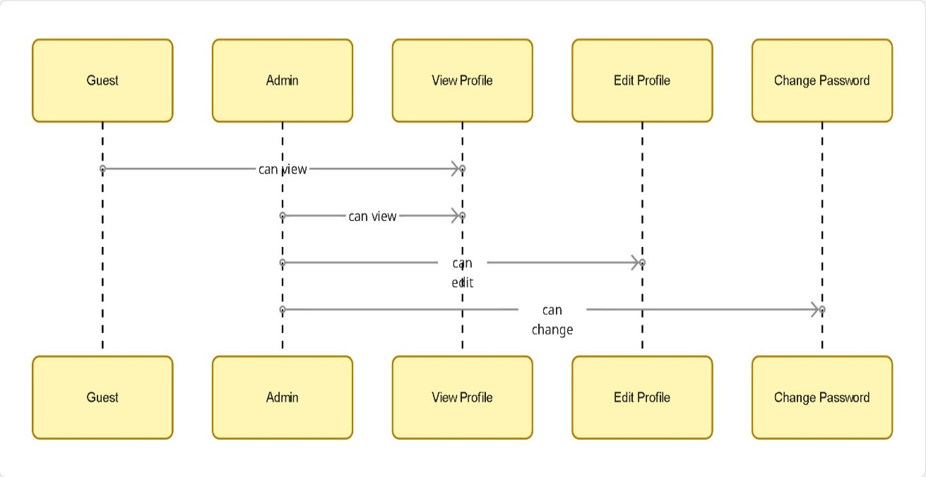

- Reporting Module
- Actor: Admin

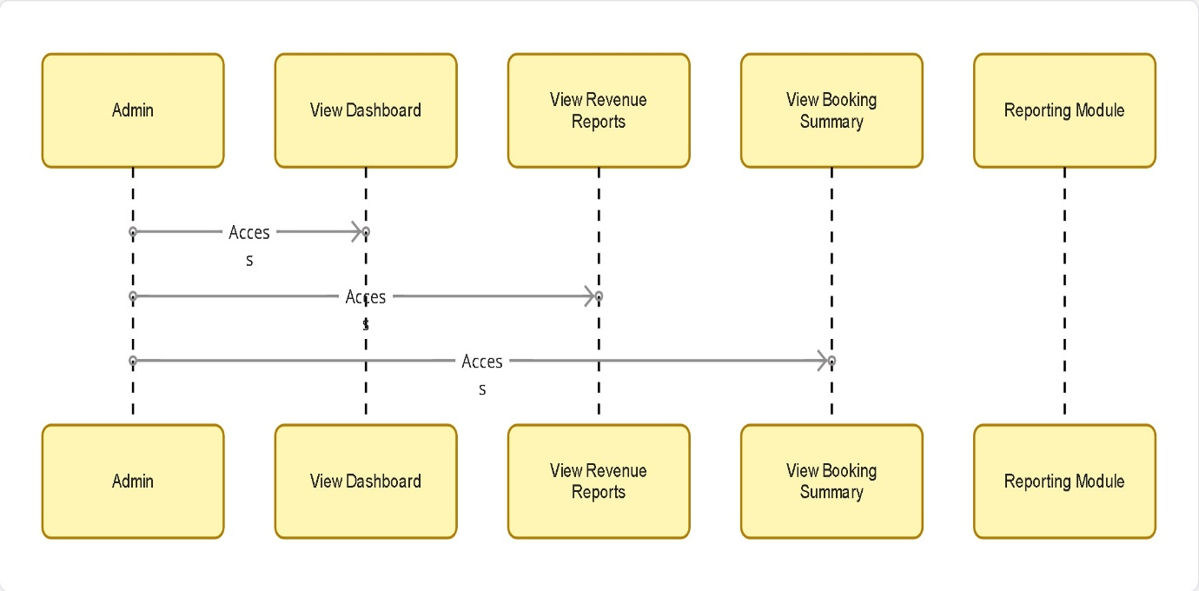
3.7 Data Flow Diagram
3.7.1 Context Level
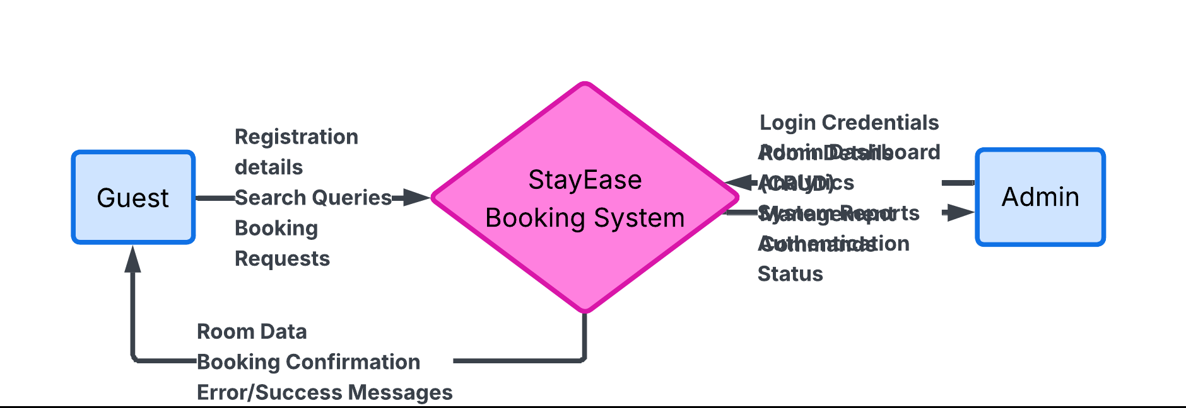

3.7.2 Level-1 DFD
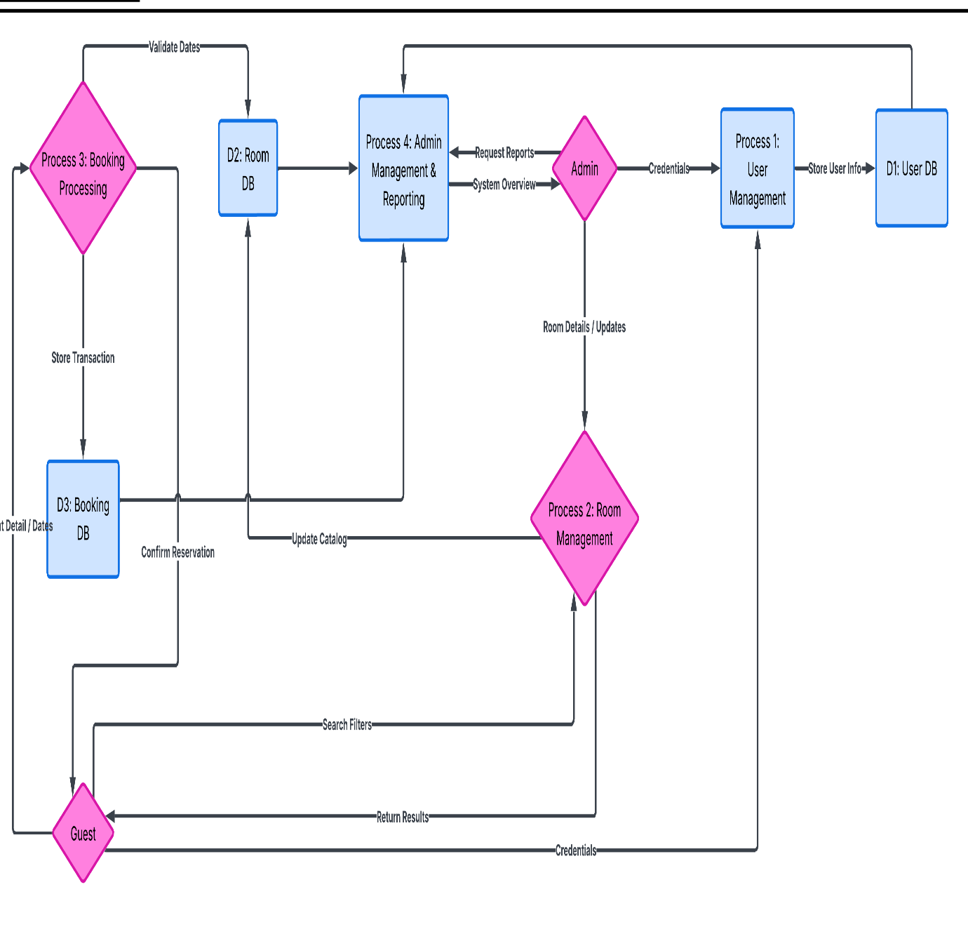

CHAPTER 4: SYSTEM DESIGN
4.1 System Architecture
The System Architecture of the StayEase application is founded on a modern, robust, and scalable 3-tier architecture. This design pattern inherently separates concerns, ensuring that modifications in one layer (such as replacing the frontend framework or migrating databases) do not necessitate a complete rewrite of the entire application.
The structure is divided into three distinct layers:
- Frontend (Presentation Tier): This tier is built using React JS. It handles the entire user interface, routing (via React Router), state management, and the presentation of dynamic data retrieved from the backend. The frontend communicates asynchronously with the underlying layer via RESTful API calls using Axios.
- Backend (Application Logic Tier): The core business logic resides here, processed by an Express.js server running in a Node.js environment. This tier securely handles authentication (JWT generation/validation), processes complex room availability queries, enforces role-based access controls for Admin routes, and orchestrates CRUD operations.
- Database (Data Storage Tier): The foundational layer responsible for data persistence. Depending on configuration, it utilizes either MongoDB (a NoSQL document database) or MySQL (a relational SQL database). This tier securely stores information about registered users, the complete room catalog, booking transactions, and associated operational metrics.
4.2 Database Design
The database schema must correctly encapsulate complex relationships, primarily managing the availability states of rooms relative to dynamic booking dates.
- Entities:
- User: Stores authentication credentials, profile information, and role designations (Guest or Admin).
- Room: Contains static details of a physical room (e.g., number, type, description, price per night) and dynamic state (e.g., image URLs, amenities).
- Booking: Represents a transaction linking a specific User to a particular Room for defined dates, including payment status.
- RoomType: Classifies rooms into categories (e.g., Suite, Deluxe, Standard).
- Amenities: A sub-entity detailing available features (Wi-Fi, Pool, AC).
1.Users Table
Field Name | Data Type | Constraints | Description
_id | ObjectId | Primary Key | Unique user identifier
name | String | NOT NULL | Full name of user
email | String | NOT NULL, UNIQUE | Email used for login
phone | String | NOT NULL | User contact number
password | String | NOT NULL | Hashed password
role | String | DEFAULT ‘guest’, check (guest/admin) | User role
loginAttempts | Number | DEFAULT 0 | Failed login attempts
lockUntil | Date | NULL allowed | Account lock expiry
CreatedAt | Date | DEFAULT current date | Account creation time

2.Rooms Table
Field Name | Data Type | Constraints | Description
_id | ObjectId | Primary Key | Unique room identifier
roomNumber | Number | NOT NULL, UNIQUE | Hotel room number
type | String | NOT NULL, CHECK(Single/Double/Deluxe/Suite) | Hotel room number
description | String | NOT NULL | Room description
price | Number | NOT NULL, CHECK(>0) | Price per night
capacity | Number | NOT NULL, CHECK(>0) | Maximum guest capacity
amenities | Array | Null allowed | List of amenities
images | Array | Null allowed | Image URLs
status | String | DEFAULT 'available', CHECK (available/maintenance) | Room availability
CreatedAt | Date | DEFAULT current date | Room creation date

3.Bookings Table
Field Name | Data Type | Constraints | Description
_id | ObjectId | Primary Key | Unique booking identifier
bookingId | String | UNIQUE | Booking reference number
user | ObjectId | FOREIGN KEY → Users(_id) | Guest making booking
room | ObjectId | FOREIGN KEY → Users(_id) | Room booked
checkin | Date | Not Null | Check-in date
checkout | Date | NOT NULL,CHECK (checkout>checkin) | Check-out date
guests | Number | NOT NULL, CHECK(>0) | Number of guests
totalPrice | Number | NOT NULL,CHECK(>0) | Total bookings price
status | string | DEFAULT ‘confirmed’ , (cancelled/checked-in/checked-out) | Booing status
transactionId | String | NULL allowed | Payment reference
CreatedAt | Date | DEFAULT current date | Booking creation date

4.Payment Table
Field Name | Data Type | Constraints | Description
_id | ObjectId | Primary Key | Unique payment ID
bookingId | ObjectId | FOREIGN KEY → Bookings(_id) | Related booking
userId | ObjectId | FOREIGN KEY → Users(_id) | User making payment
amount | Number | NOT NULL, CHECK(>0) | Payment amount
paymentMethod | String | NOT NULL,CHECK(Credit card/Debit card/UPI) | Method used
transactionId | String | UNIQUE | Generated transaction ID
status | String | DEFAULT ‘paid’, CHECK (paid/failed) | Payment status
createdAt | Date | DEFAULT current date | Payment timestamp

5.Notifications Table
Field Name | Data Type | Constraints | Description
_id | ObjectId | Primary Key | Notification ID
userId | ObjectId | FOREIGN KEY → Users(_id) | Notification receiver
email | String | NOT NULL | Recipient email
subject | String | NOT NULL | Email subject
Message | String | NOT NULL | Email content
type | String | NOT NULL | Notification type
Created At | Date | DEFAULT current date | Notification time

4.3 ER Diagram
- Main Entities
- USER
- ROOM
- BOOKING
- PAYMENT
- NOTIFICATION
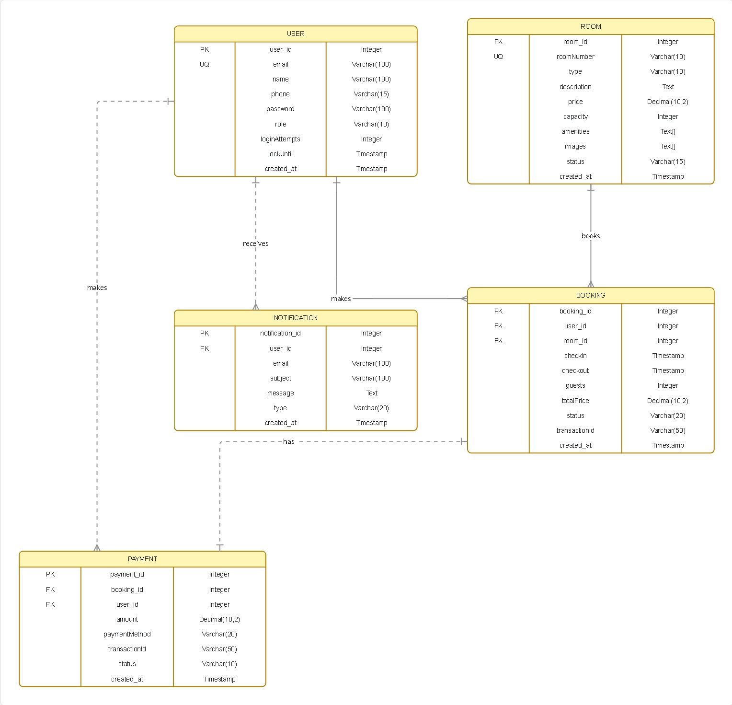

4.4 Class Diagram
The Class Diagram delineates the system's object-oriented structure. It details the classes, their essential attributes, and the methods defining their behaviours.
- User Class
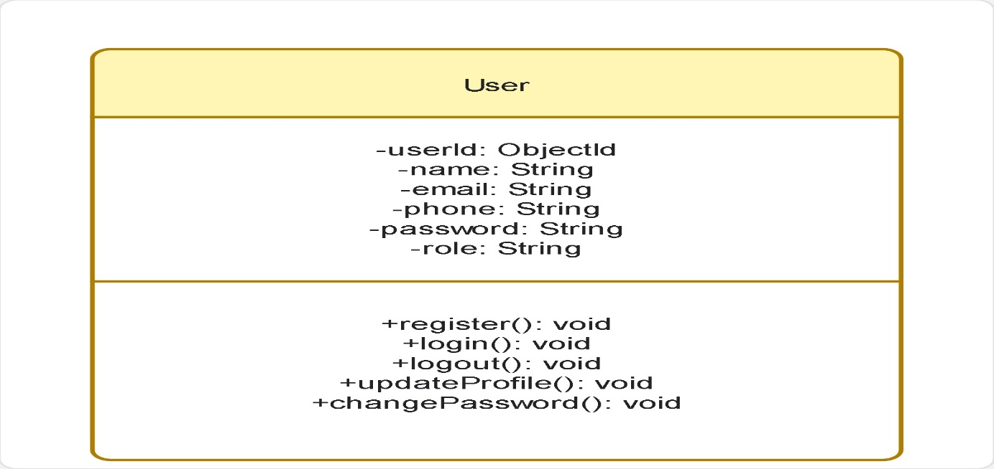

2. Room Class
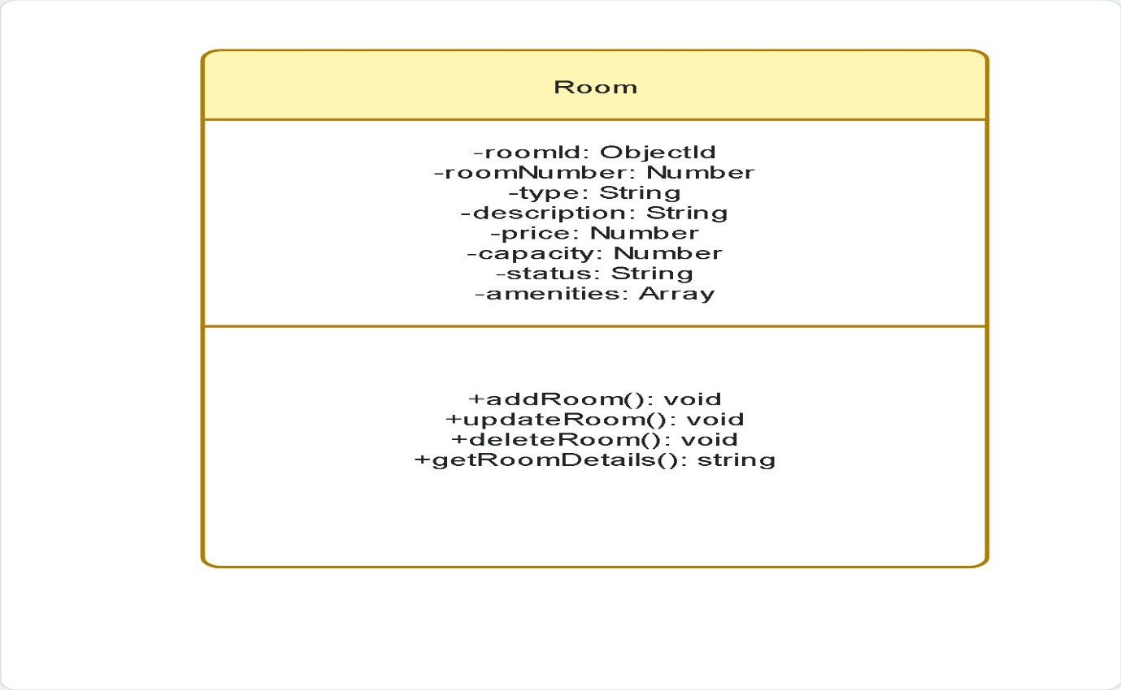

3. Booking Class
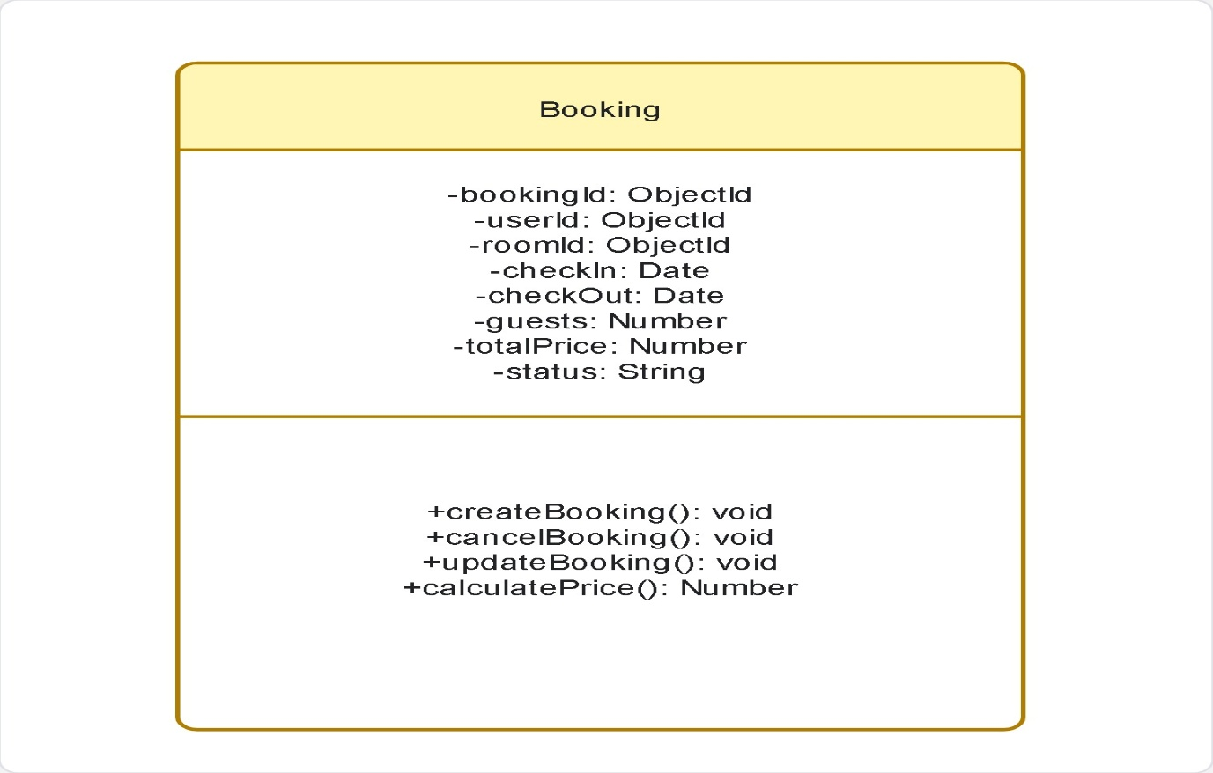

- Payment Class
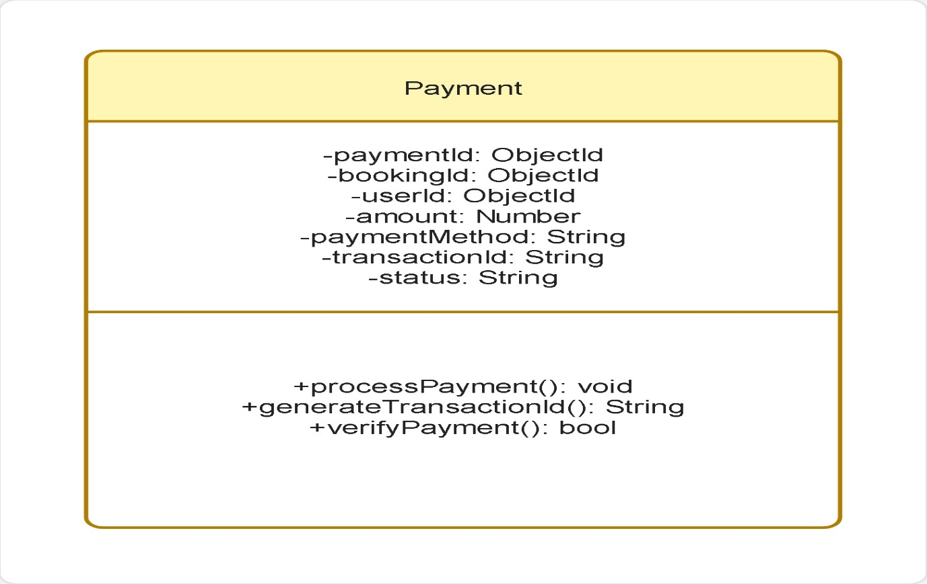

- Admin Class (Inherits User)
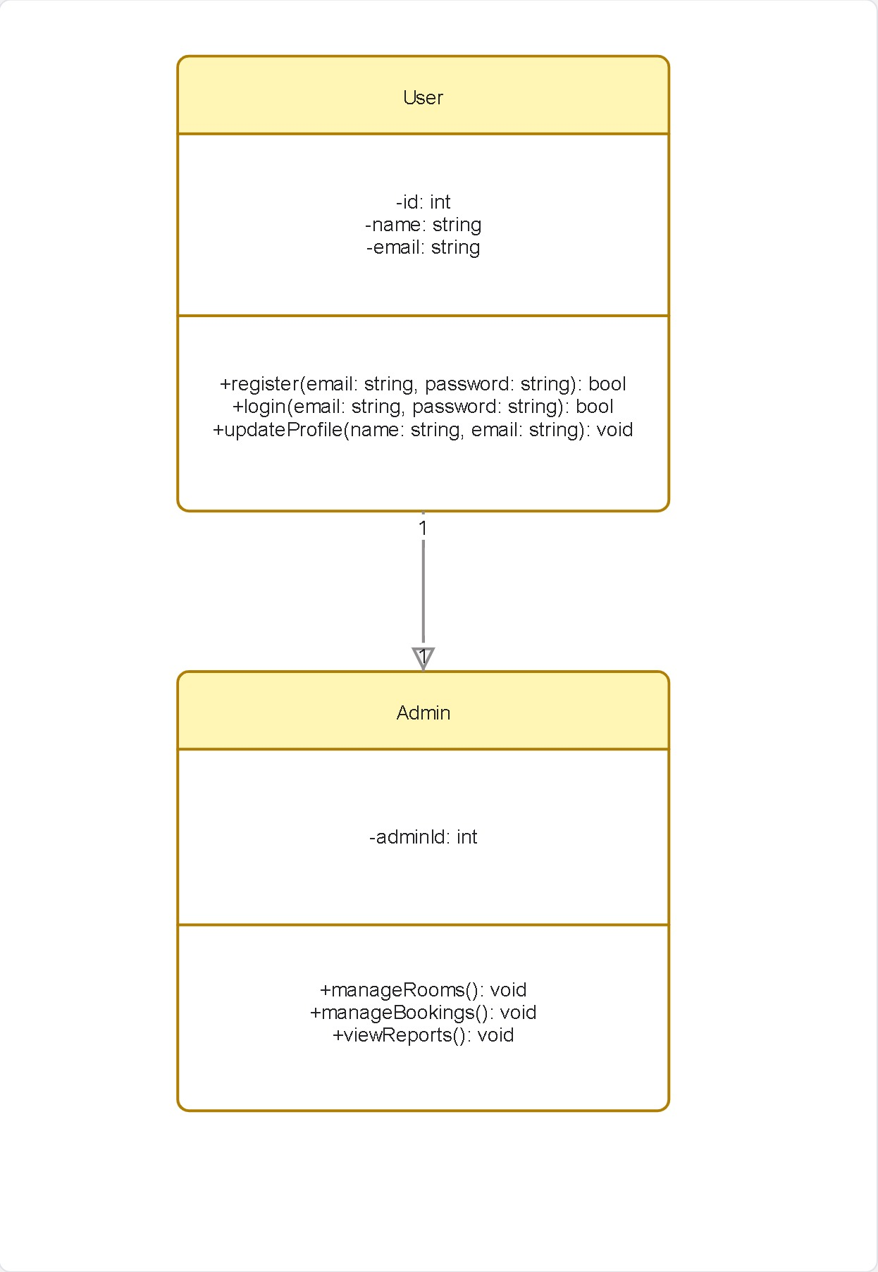
- Notification Class
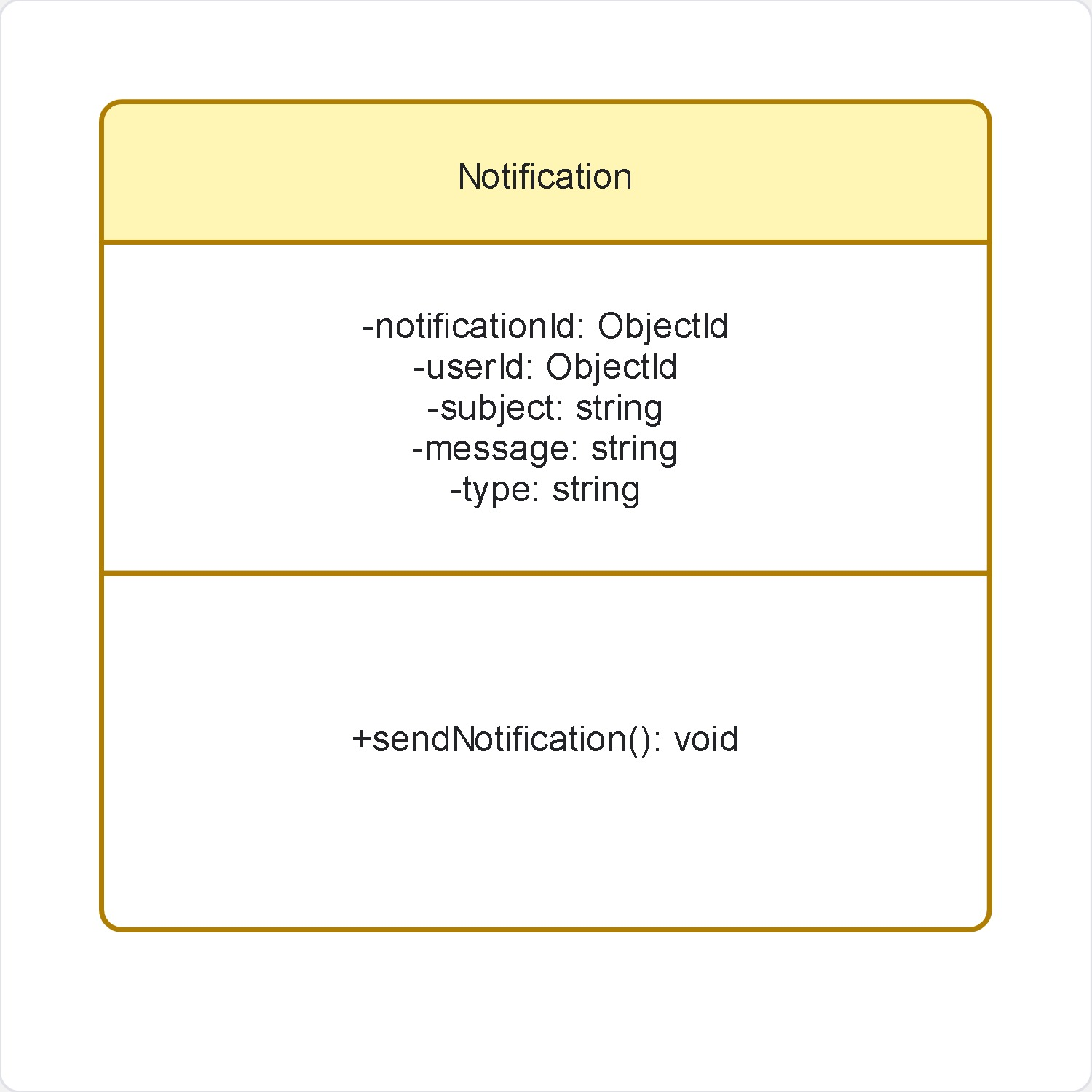

- Relationships
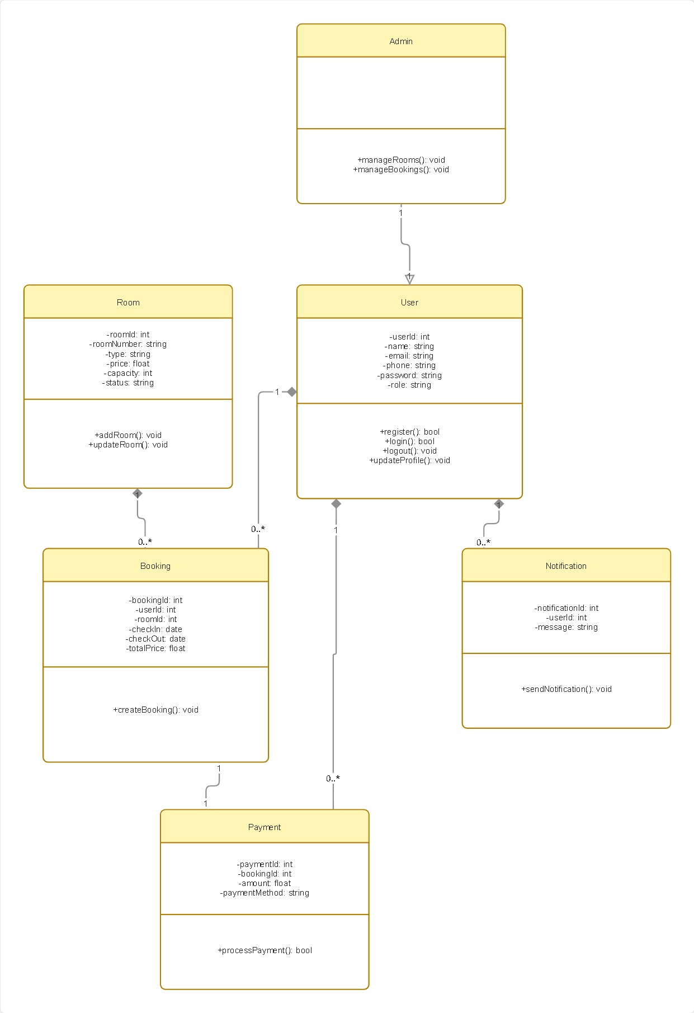

4.5 Sequence Diagrams
Sequence diagrams illustrate the time-ordered interaction between objects during a specific operation.

1. User Authentication (Register/Login)
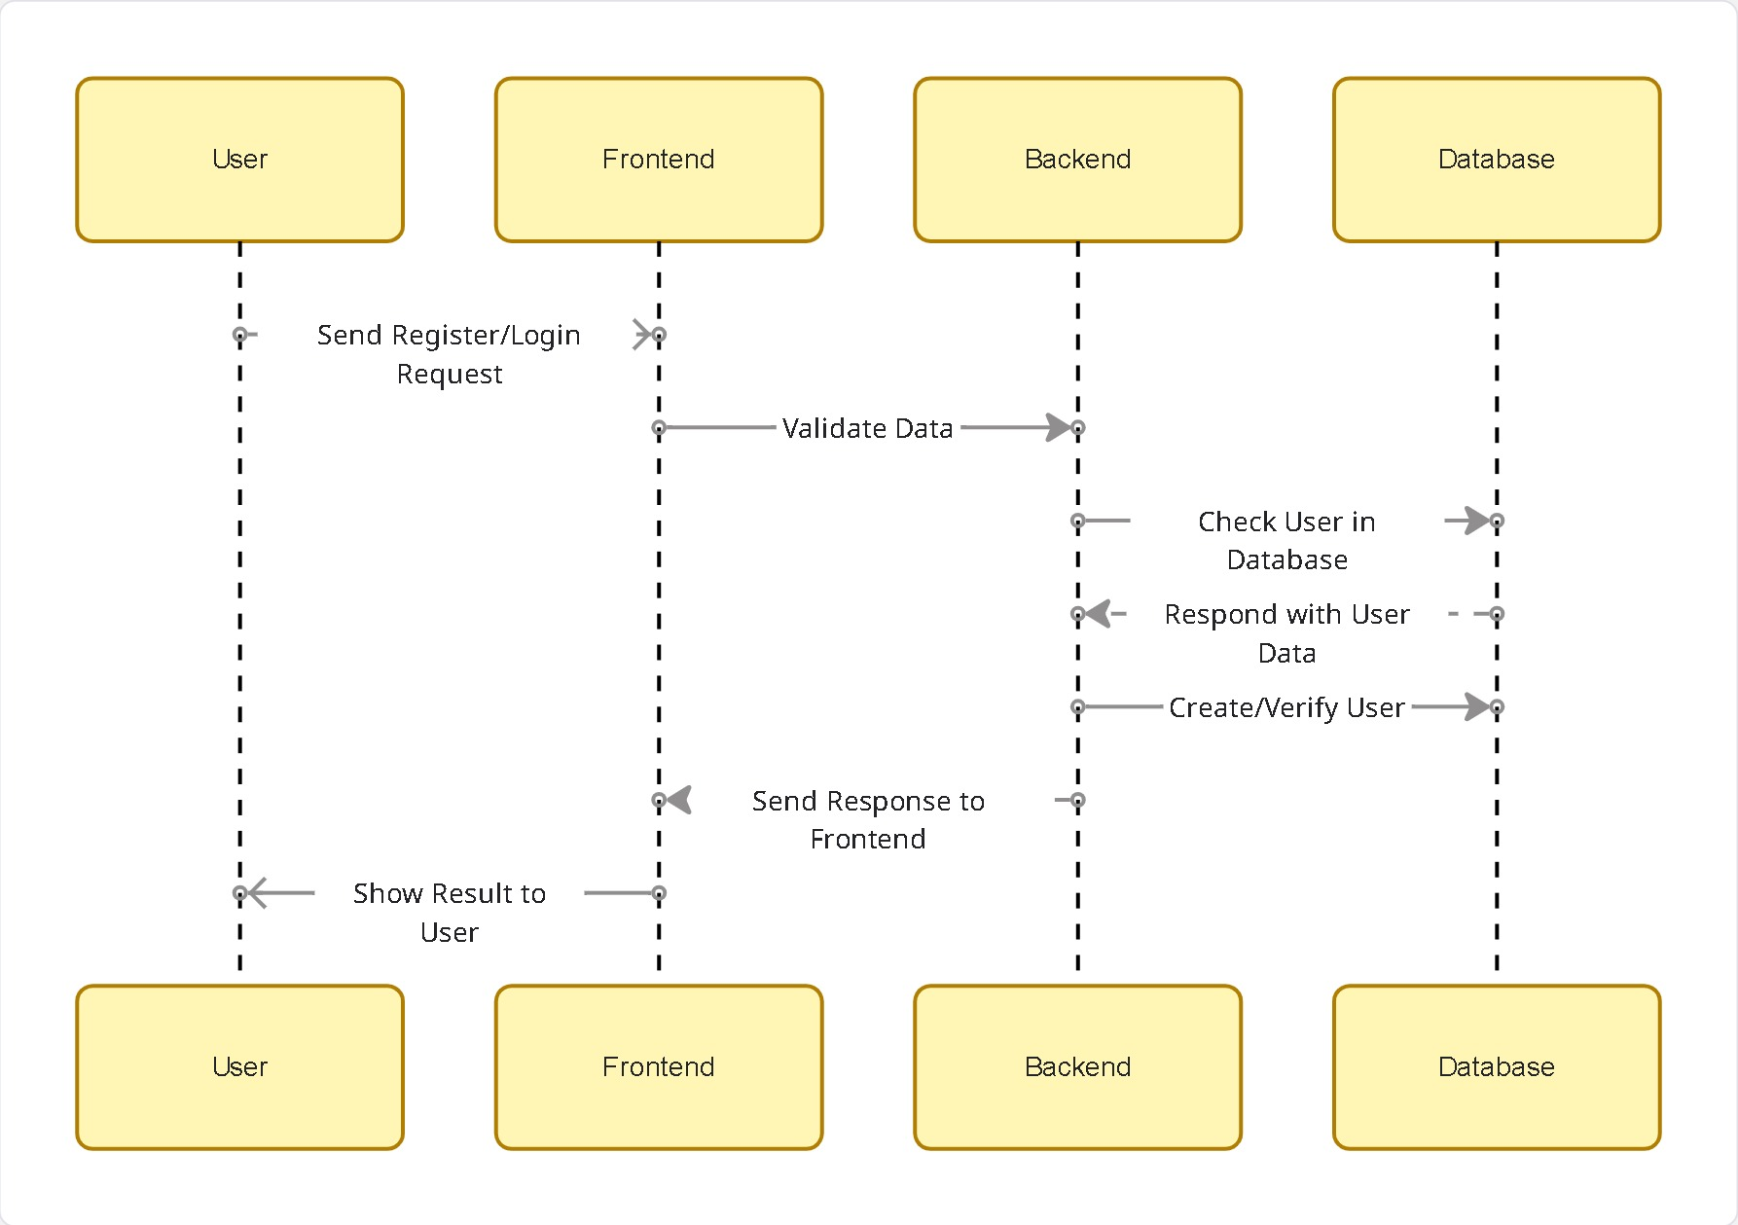
2. Room Search & View
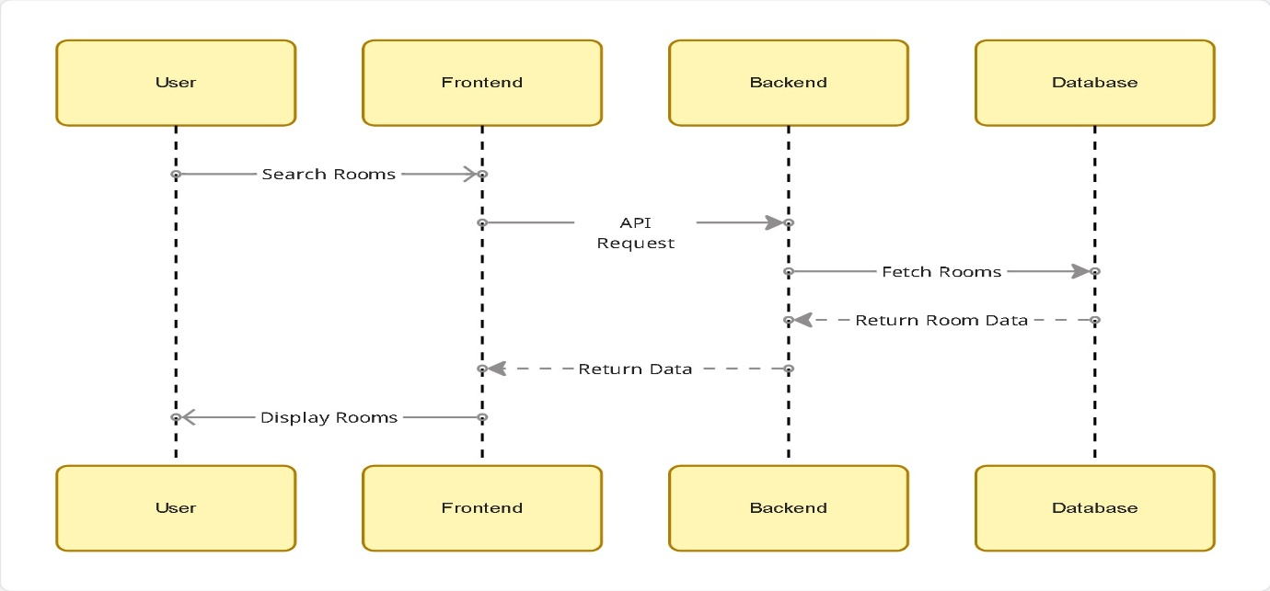
3. Booking Module
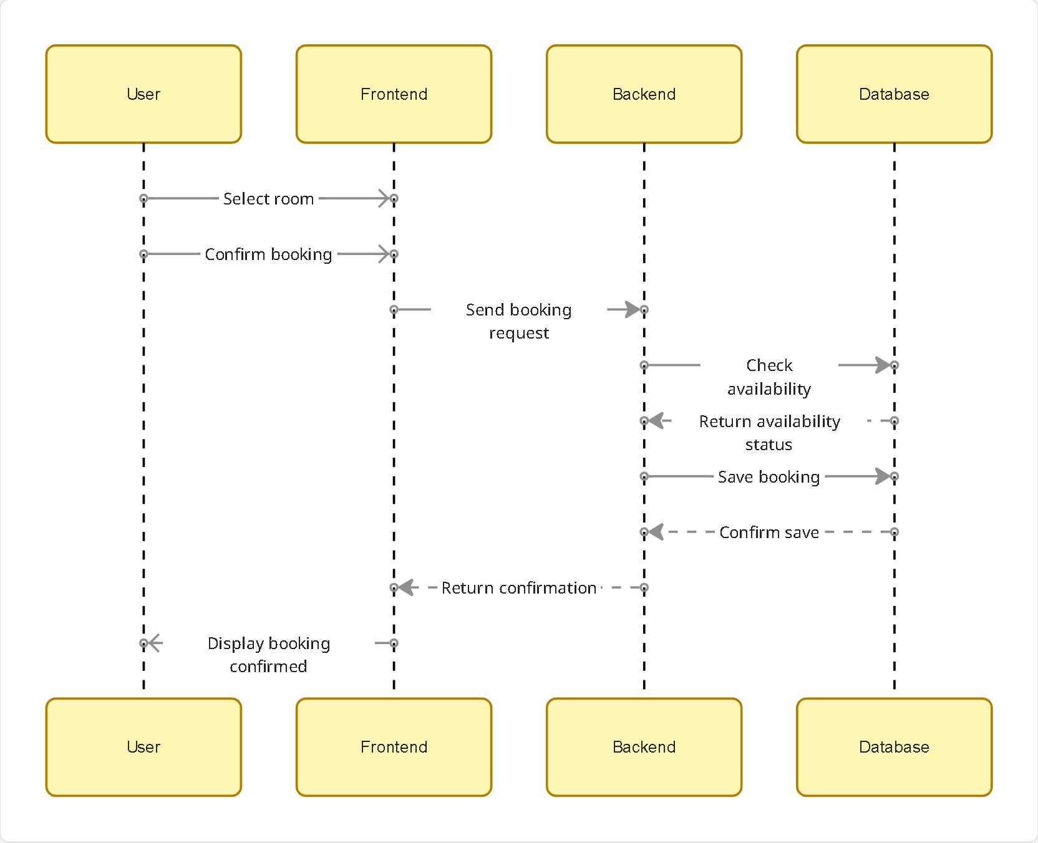

4. Payment Module (Simulated)
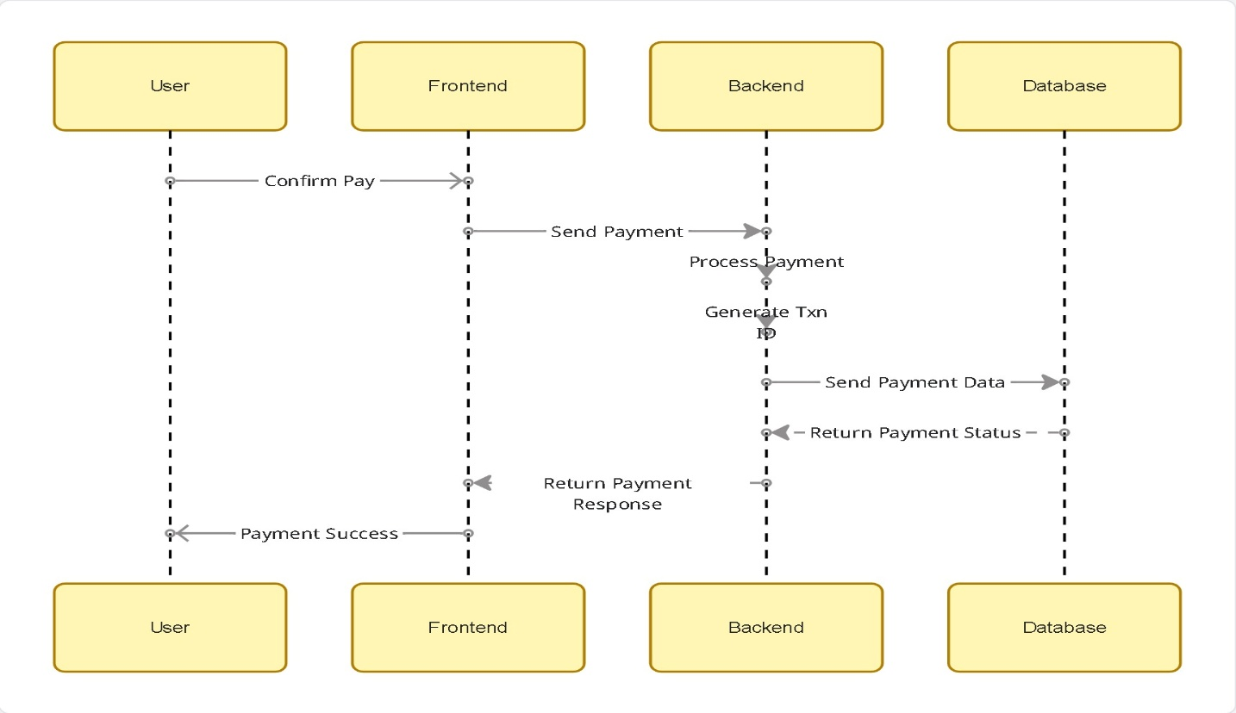

5. Admin Room Management
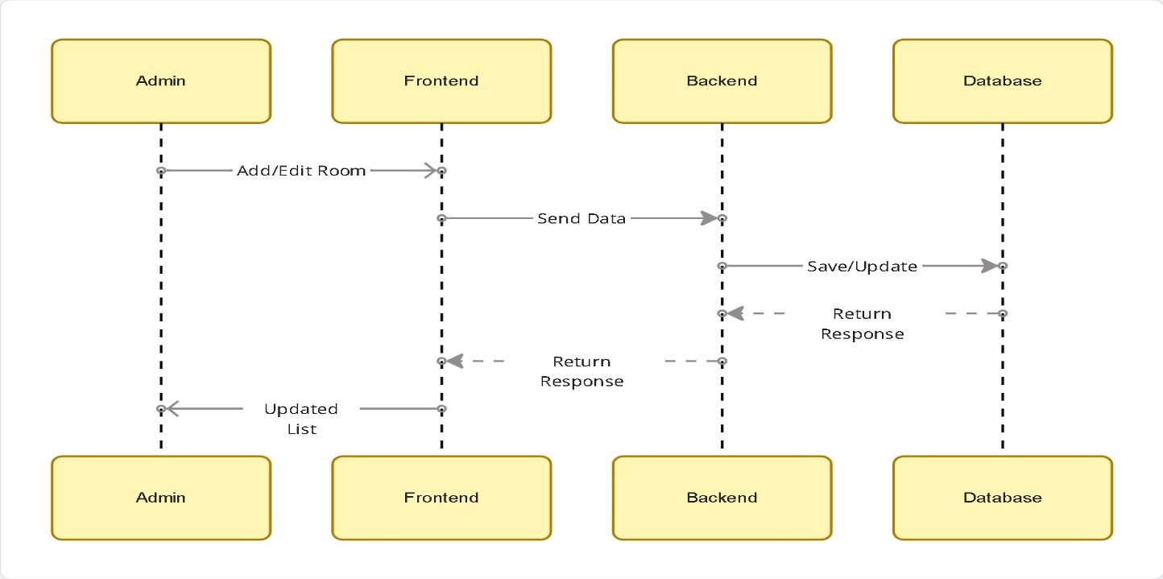

6. Admin Booking Management
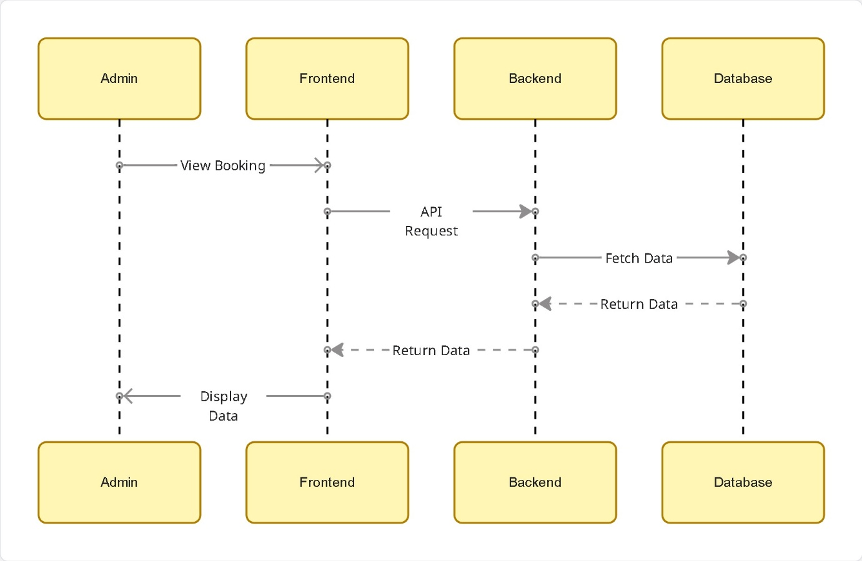

7. Profile Update Module
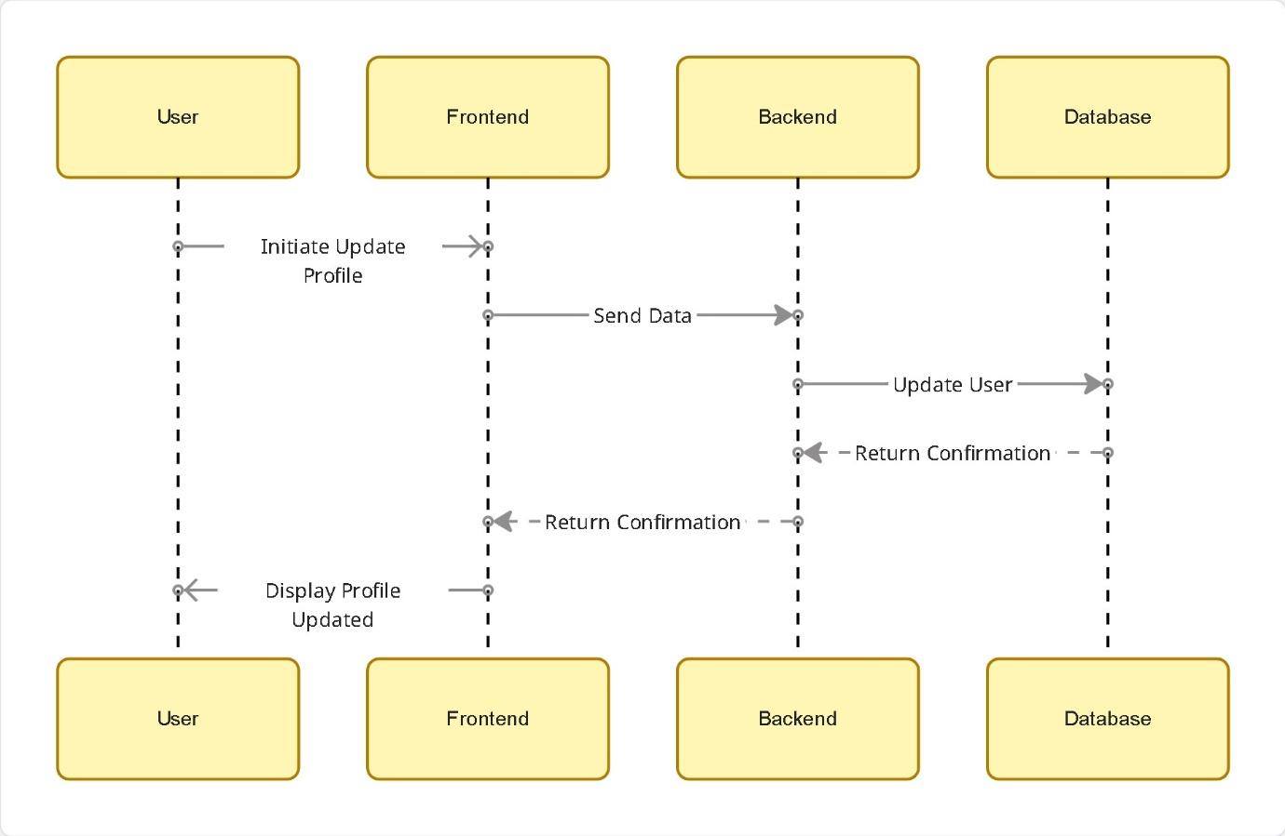

4.7 Component Diagram
- A Component Diagram is a type of UML diagram that shows the overall structure of a system by dividing it into different components and showing how these components interact with each other.
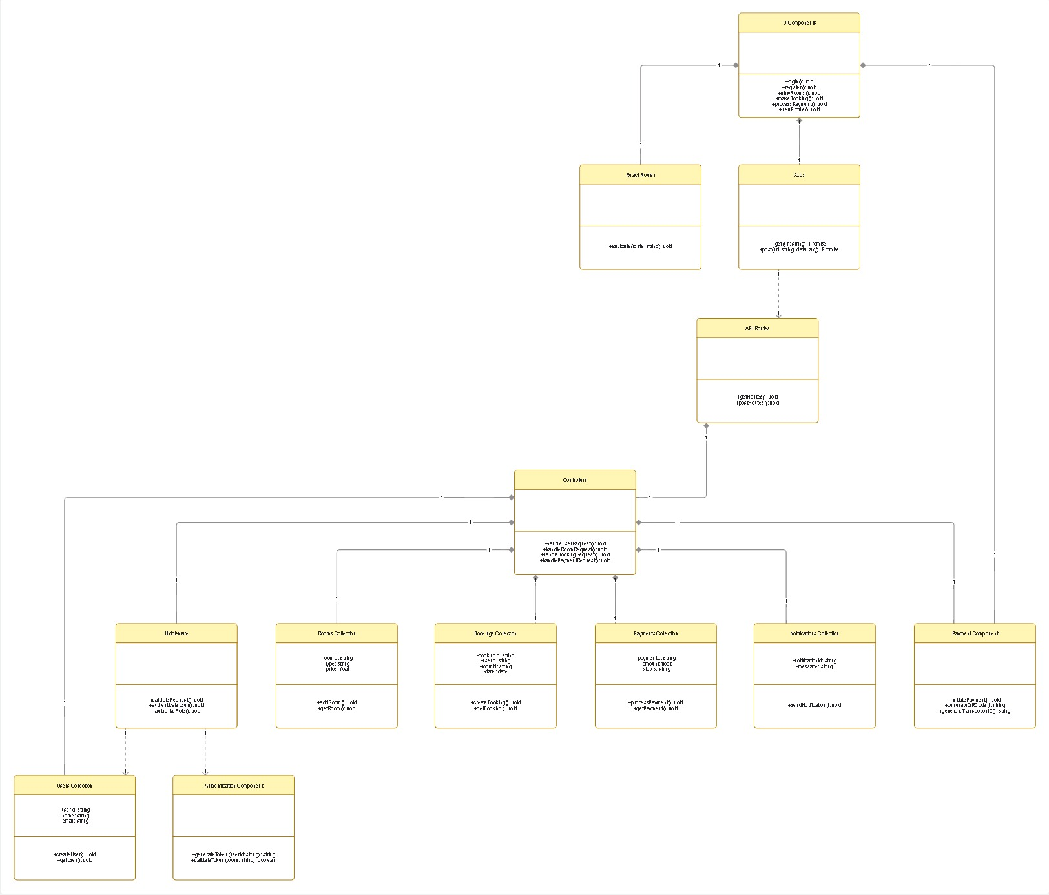

4.7 Deployment Diagram
- A Deployment Diagram specifies how software artifacts are mapped onto hardware architecture configurations for production execution.
- Deployment diagram shows how the system is physically deployed. The client interacts through a browser, frontend is hosted using React, backend runs on Node.js server, and data is stored in MongoDB Atlas cloud database.
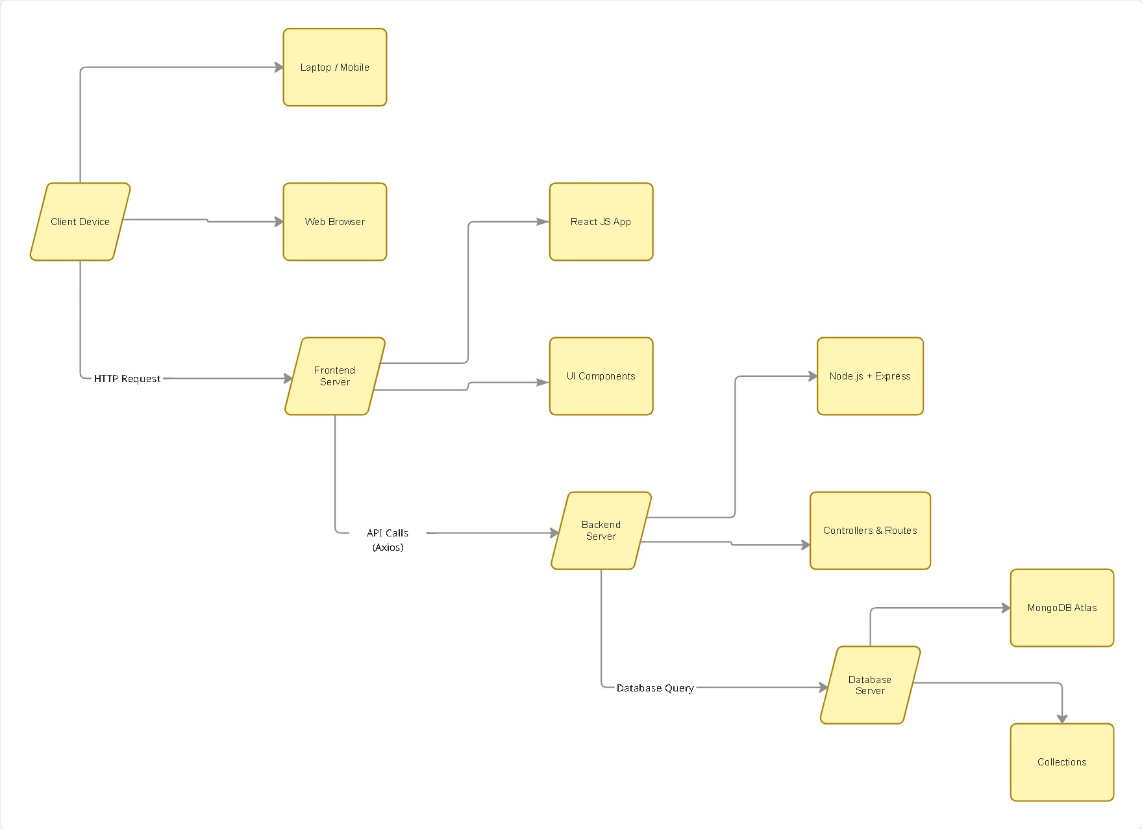

4.8 User Interface Design
Figure 4.8.1: Home Page
Description: The homepage provides an overview of the StayEase platform with a search feature that allows users to select check-in/check-out dates and number of guests to find available rooms.
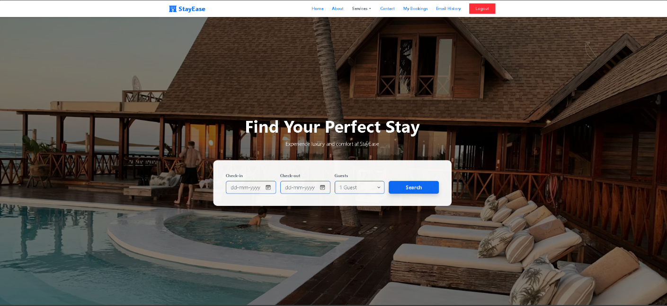

Figure 4.8.2: About Us Page
Description: This page describes the StayEase platform, highlighting its purpose, features, and benefits for users seeking a seamless hotel booking experience.
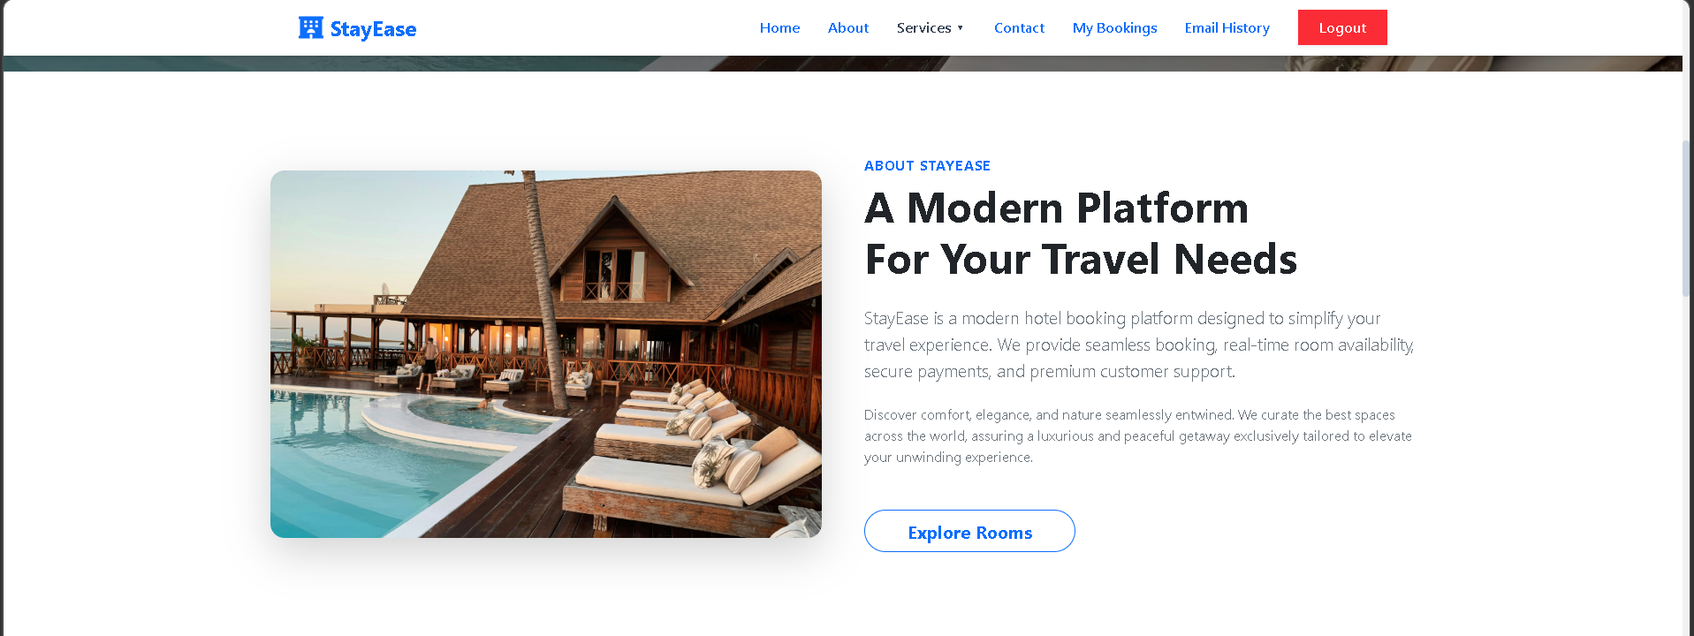

Figure 4.8.3: Rooms Listing Page
Description: Displays all available rooms with filtering options such as check-in date, check-out date, room type, and number of guests.
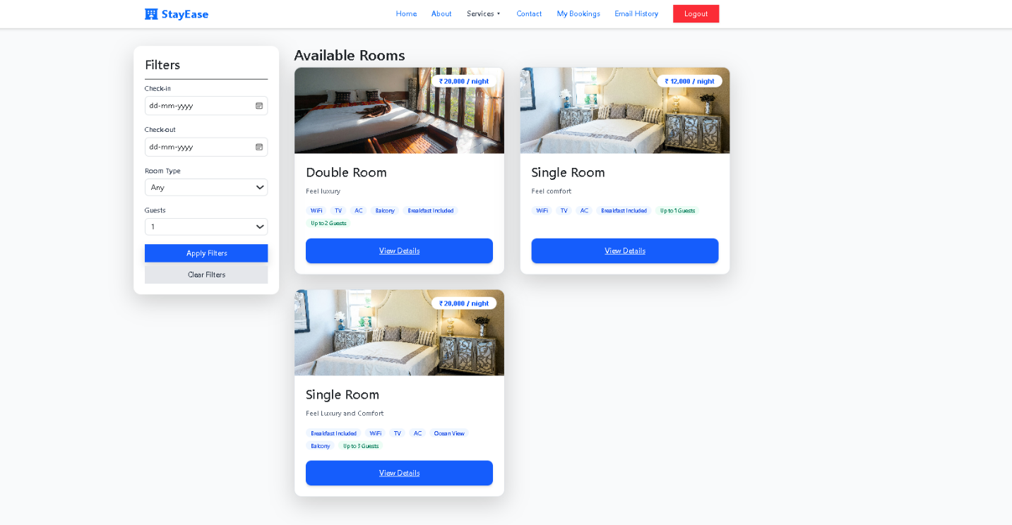
Figure 4.8.4: Rooms Details Page
Description: Shows detailed information about a selected room, including images, amenities, pricing, and booking options.
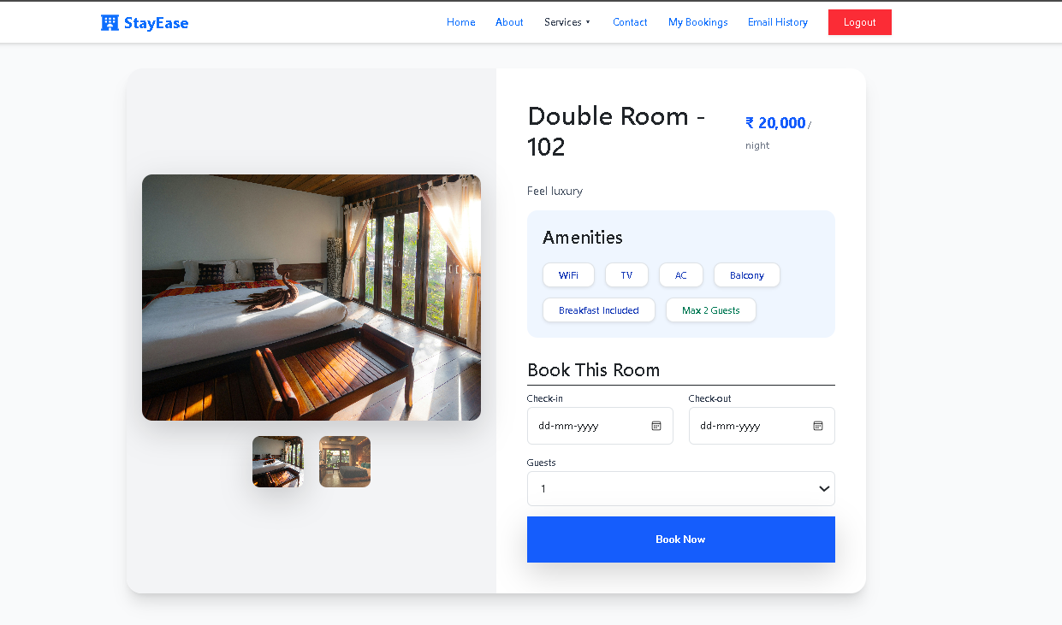
Figure 4.8.5: Booking Summary Page
Description: Shows detailed information about a selected room, including images, amenities, pricing, and booking options.
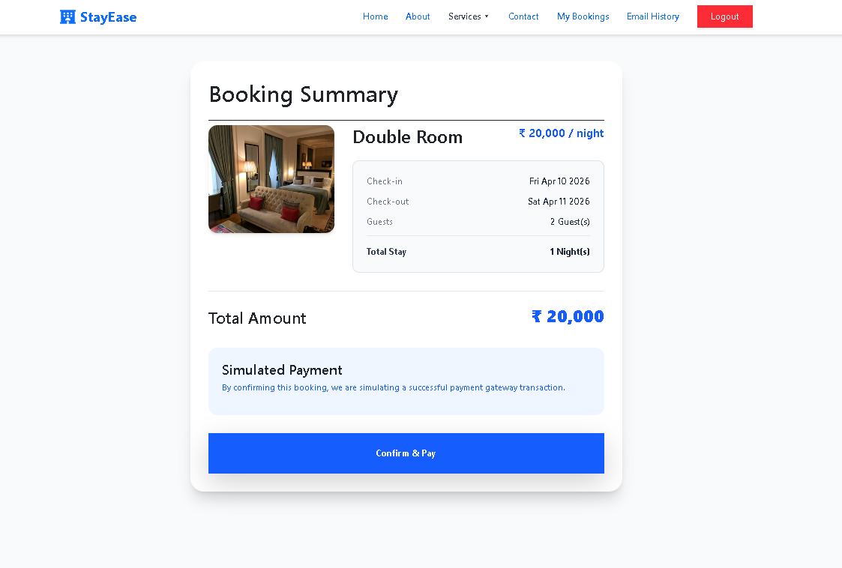

Figure 4.8.6: Secure Payment Page(UPI)
Description: Allows users to complete payment using UPI with QR code scanning and transaction validation.
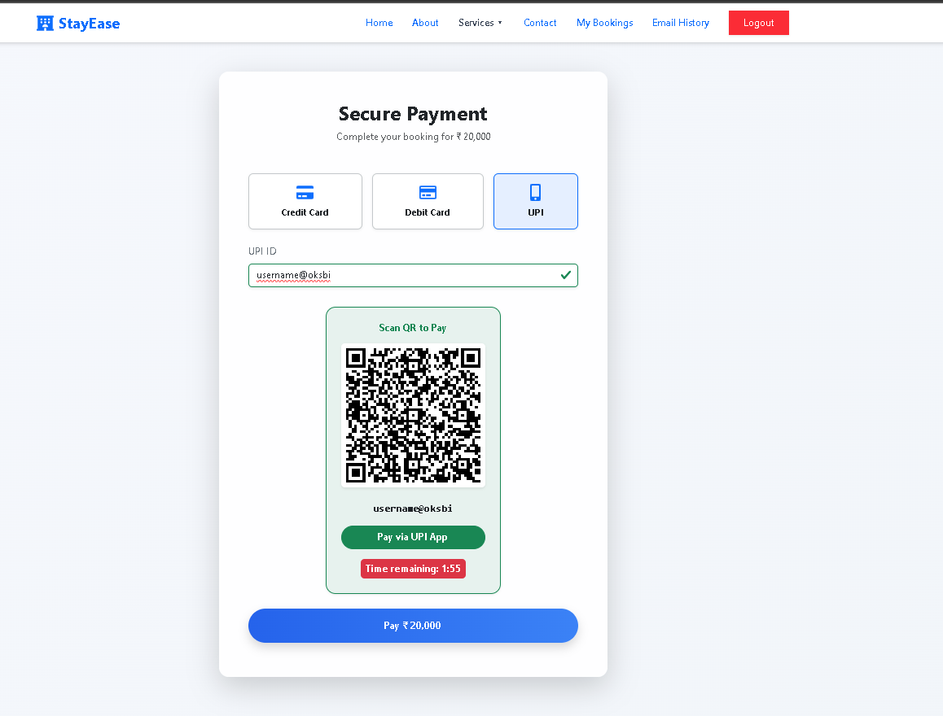
Figure 4.8.7: Secure Payment Page(CARD)
Description: Enables users to pay using credit/debit cards by entering card details securely.
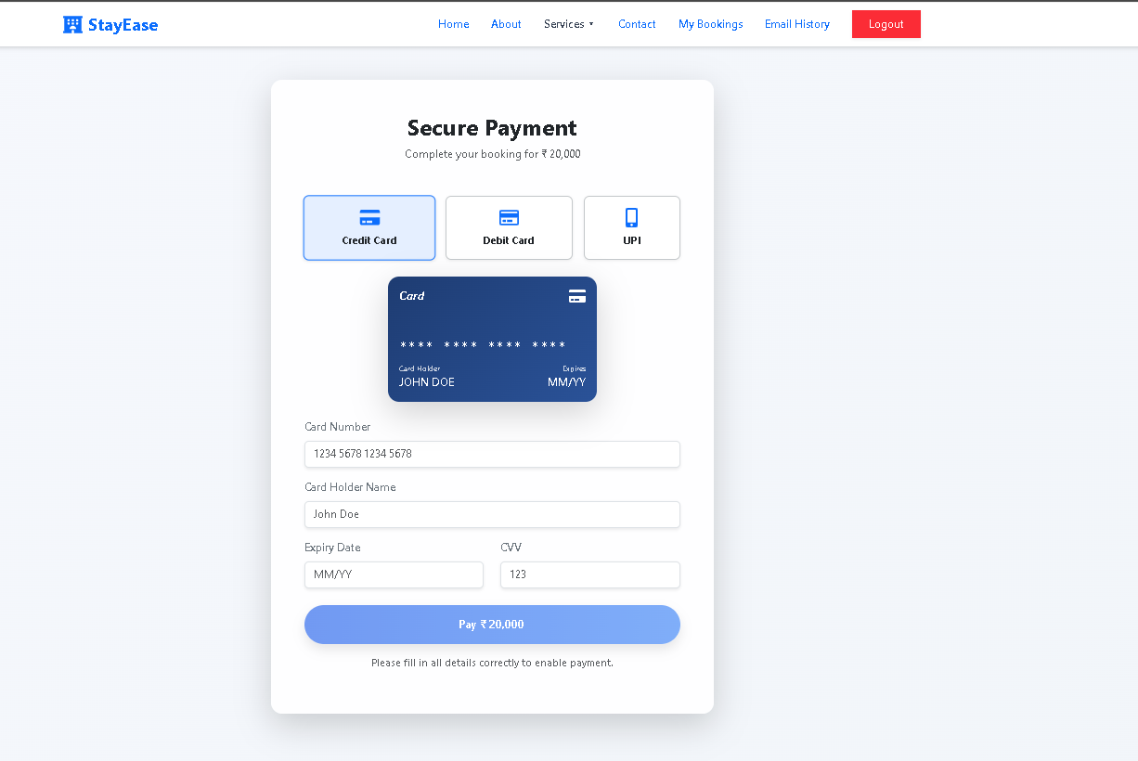

Figure 4.8.8: Booking Confirmation (Email Simulation)
Description: Displays a confirmation popup after successful booking, including booking ID, transaction ID, and payment details.
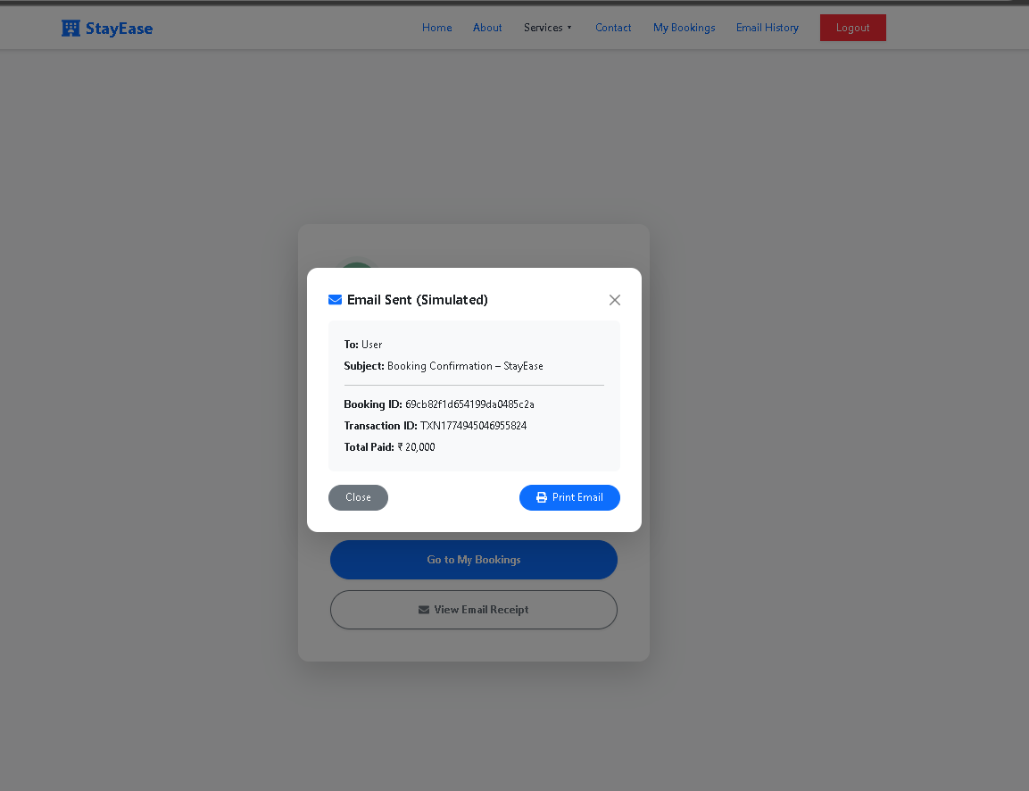
Figure 4.8.9: My Bookings Page
Description: Allows users to view their booked rooms, including check-in/out dates, total price, and cancellation options.
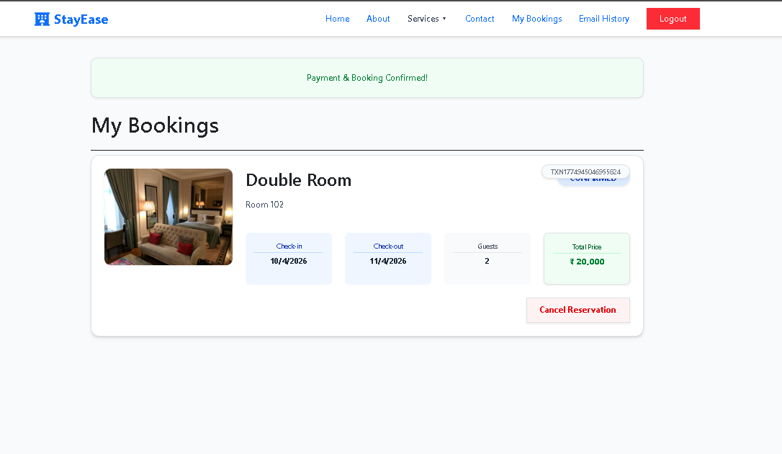
Figure 4.8.10: Contact Us Page
Description: Provides a form for users to send queries or feedback along with contact details of the StayEase platform.
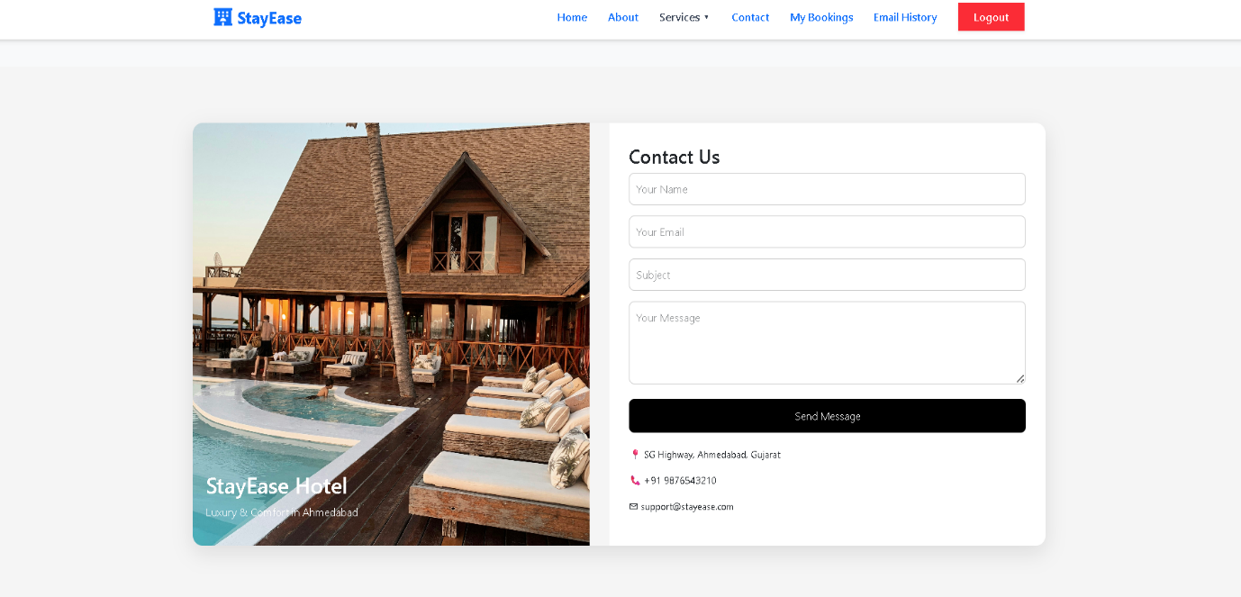

👨‍💼 ADMIN MODULE
Figure 4.8.11: Admin Login Page
Description: Secure login interface for administrators to access the system dashboard.
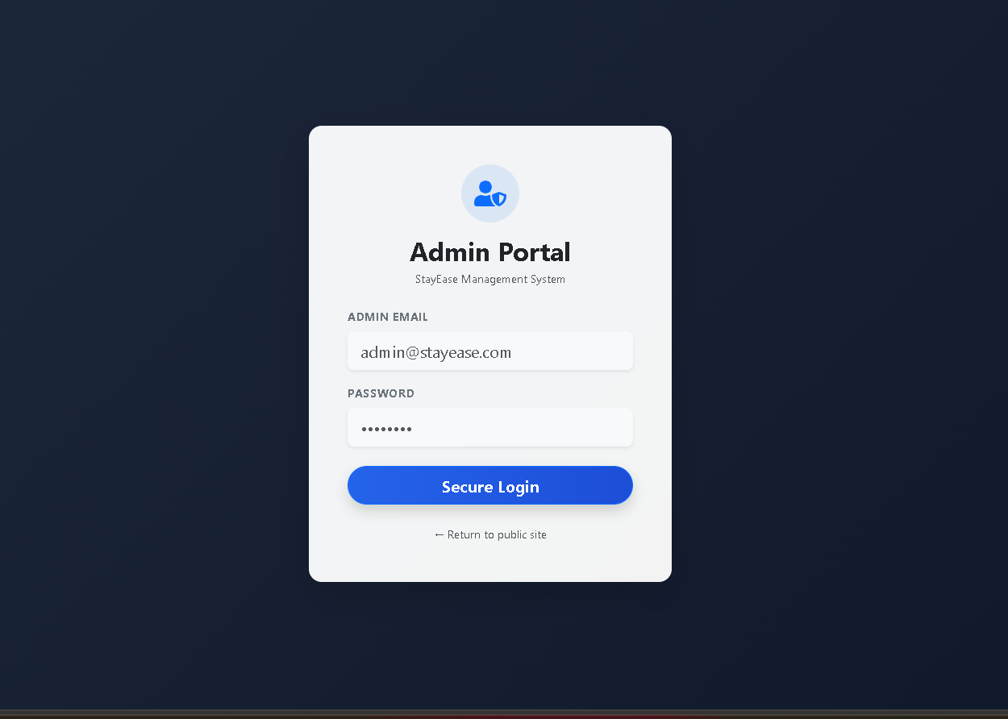
Figure 4.8.12: Admin Dashboard
Description: Displays key statistics such as check-ins, check-outs, bookings, occupancy rate, and revenue analytics.
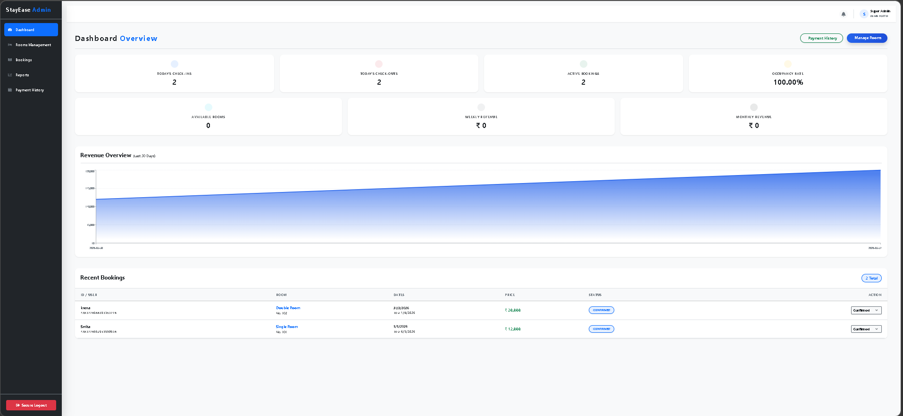
Figure 4.8.13: Rooms Management Page
Description: Allows admins to manage rooms, including viewing, editing, and disabling room availability.
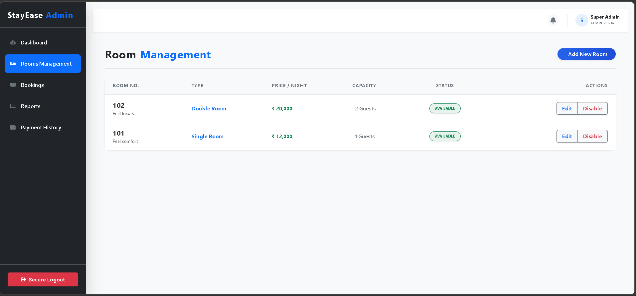
Figure 4.8.14: Create New Room
Description: Form interface for adding new rooms with details like room type, price, capacity, amenities, and images.
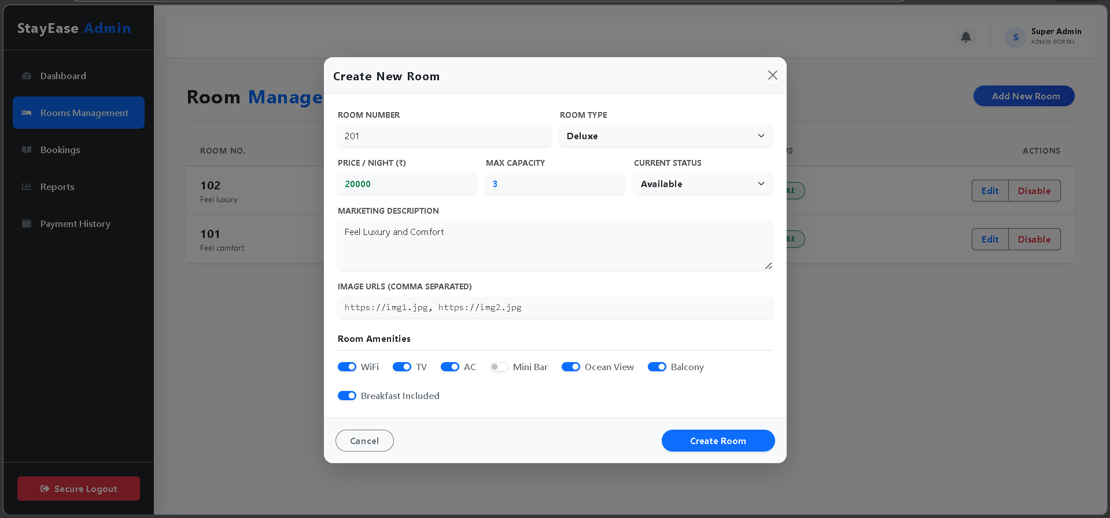

Figure 4.8.15: Edit Existing Rooms
Description: Allows administrators to update room details such as pricing, description, and availability.
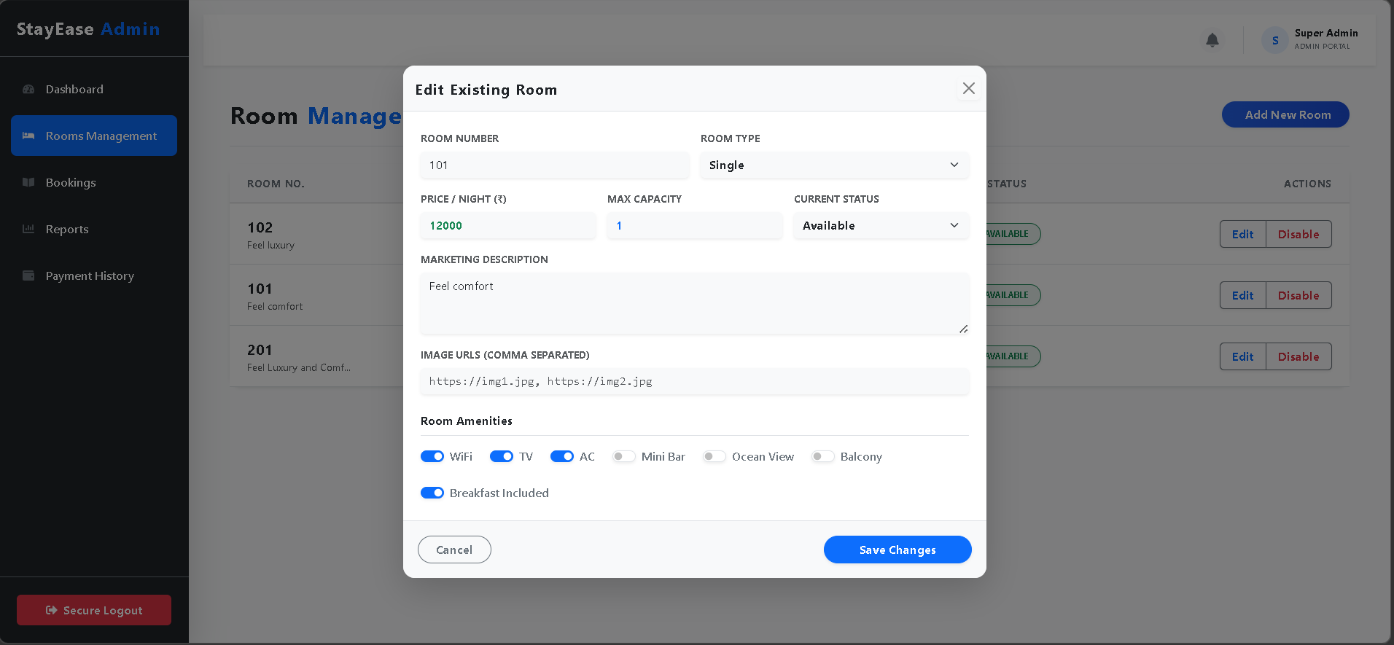
Figure 4.8.16: Bookings Master List
Description: Displays all bookings with guest details, room information, booking dates, and status management options.
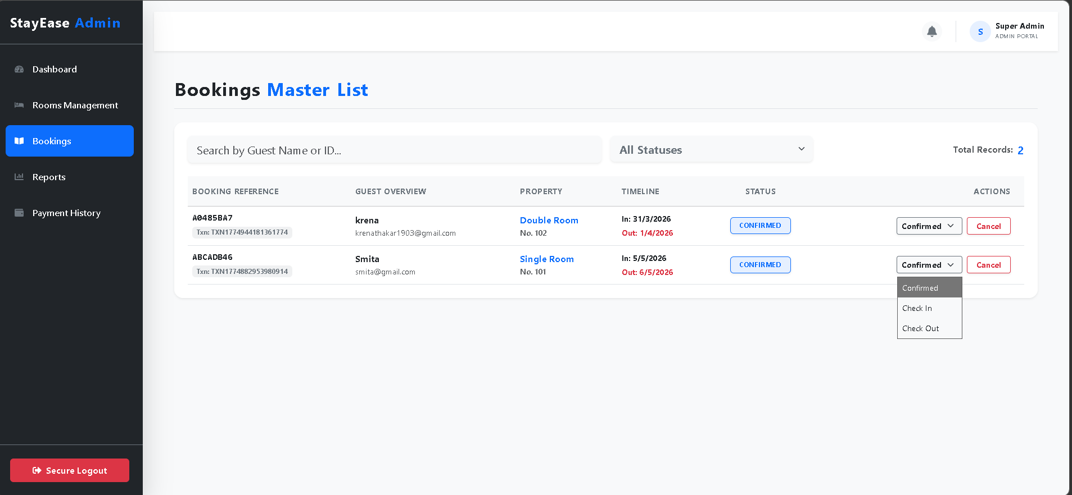

Figure 4.8.17: Payment History Page
Description: Shows all completed transactions with details like transaction ID, payment method, amount, and status.
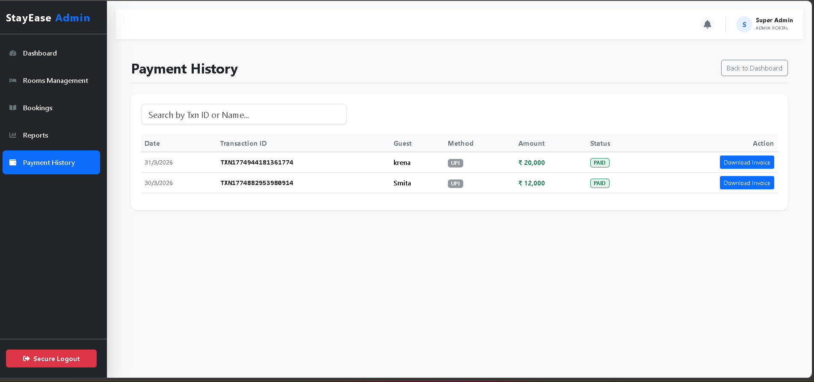
Figure 4.8.18: Reports And Analytics Page
Description: Provides insights into revenue, occupancy rate, and booking trends using graphical charts.

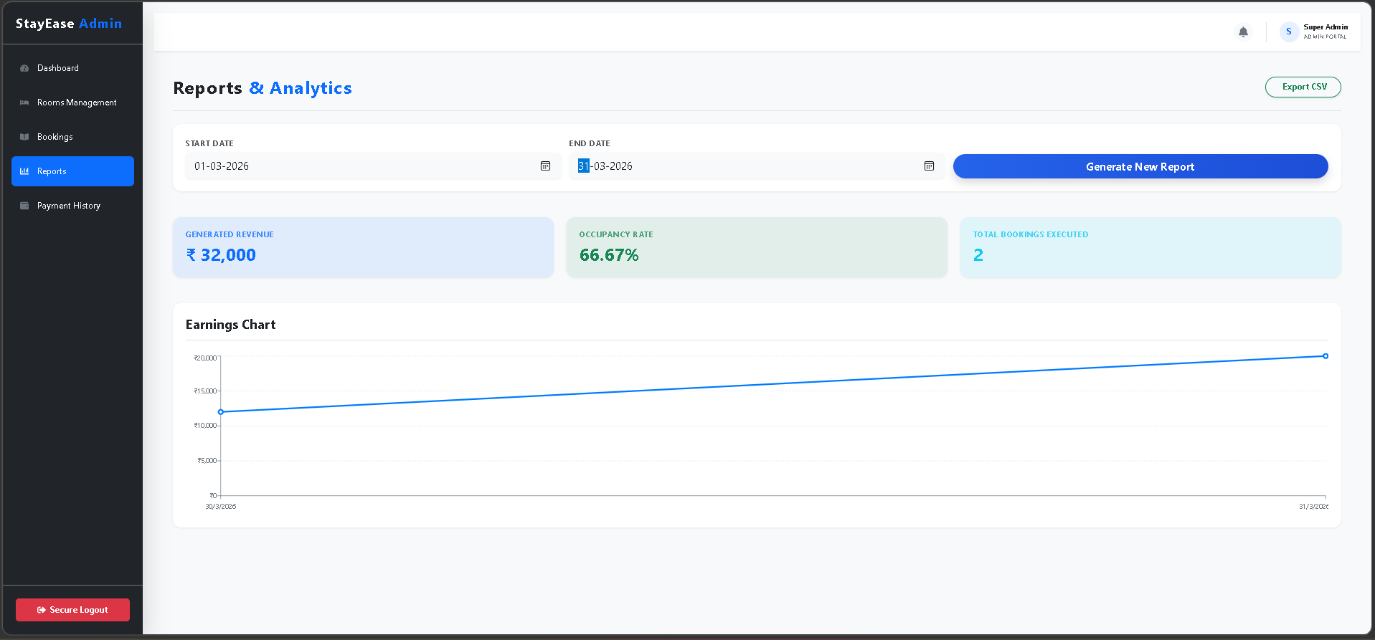

👤 USER AUTHENTICATION
Figure 4.8.19: User Login Page
Description: Allows registered users to log in securely using their email and password.
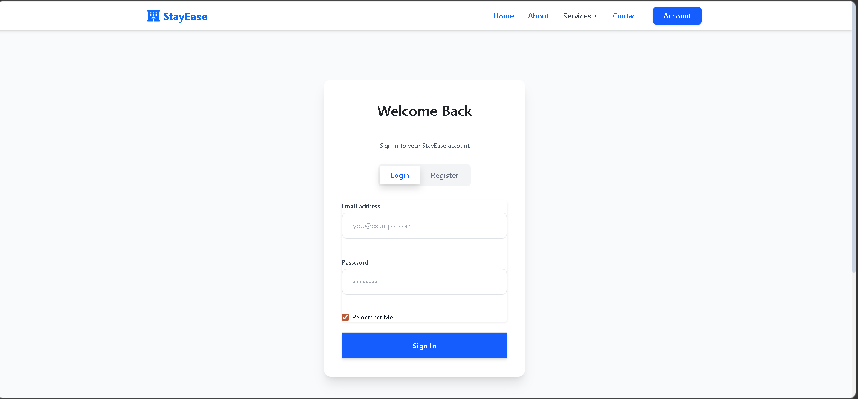
Figure 4.8.20: User Registration Page
Description: Enables new users to create an account by providing personal details such as name, email, phone number, and password.
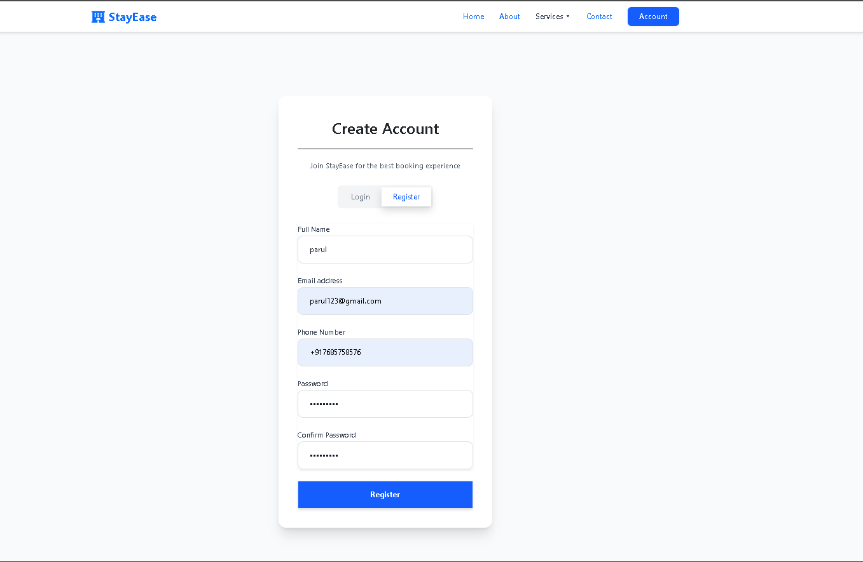
Figure 4.8.21: Services Page
Description: This page highlights the key services offered by the StayEase platform, including luxury rooms, 24/7 customer support, secure booking, and flexible refund policies. It helps users understand the value and features provided by the system.
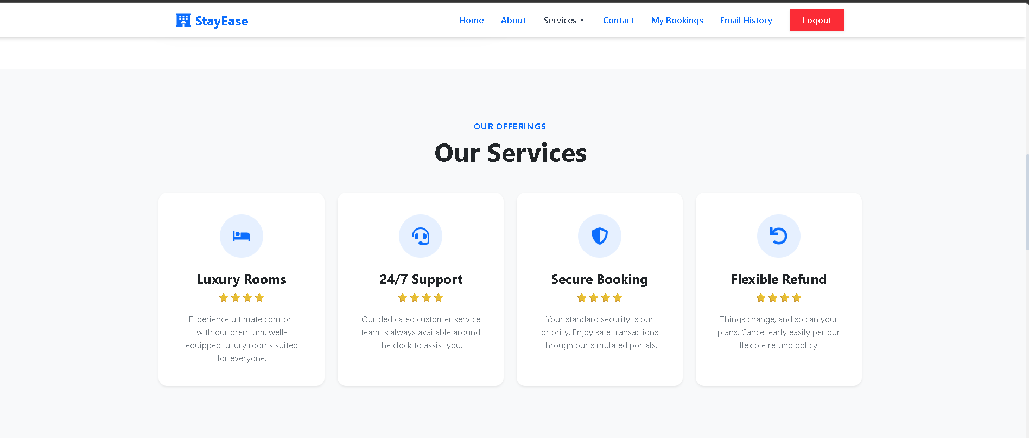
Figure 4.8.22: Registration Confirmation Email(Simulated)
Description: This screen displays a simulated email confirmation sent to the user after successful account registration. It includes a welcome message and confirms that the user account has been created successfully.
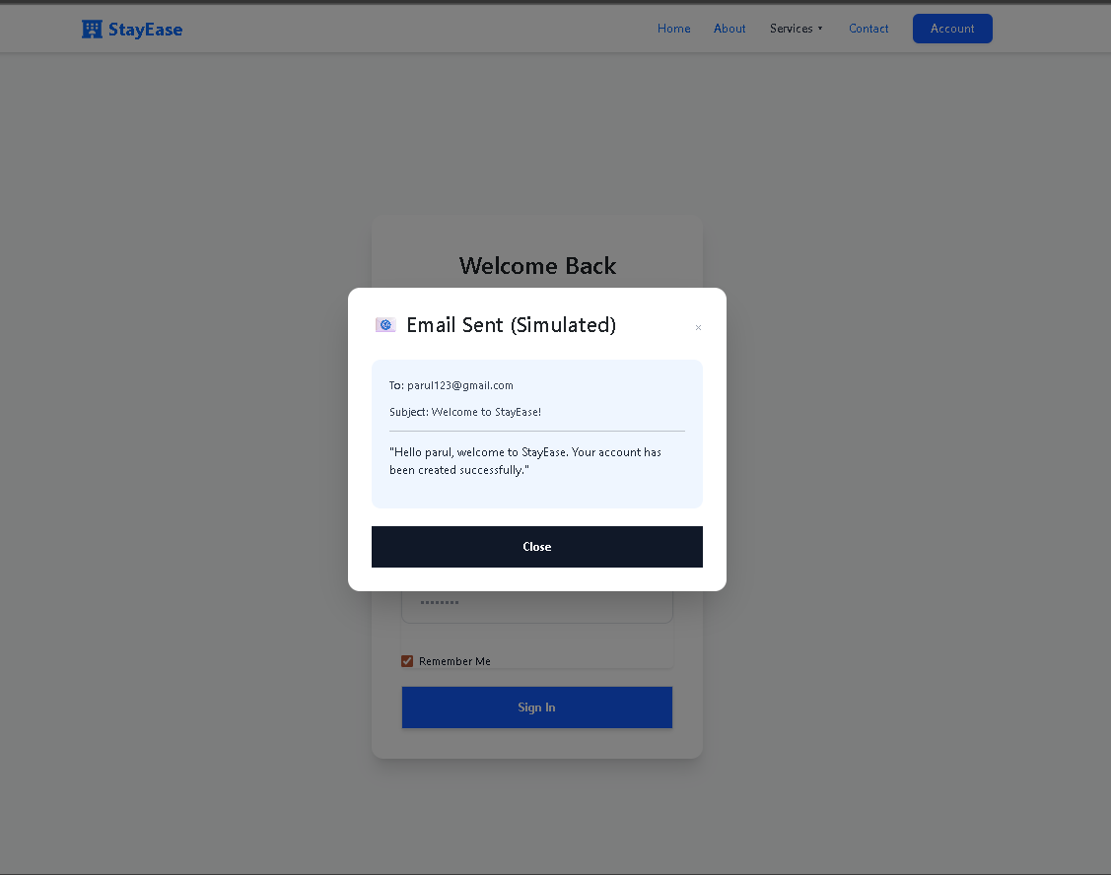

4.9 Project Timeline
Phase | Week(s) | Phase Name | Focus Area | Key Activities
1 | 1 | Project Initiation & Requirements | Planning | Requirements finalization, technology setup, design planning
2 | 2 | System Design | Design | Architecture design, database design, UI/UX mockups
3 | 3-4 | Core Development I | Development | Authentication, room catalog, basic UI components
4 | 5-6 | Core Development II | Development | Booking system, admin panel, payment simulation
5 | 7 | Testing & Integration | Quality | Testing, bug fixes, performance optimization
6 | 8 | Documentation & Submission | Completion | Documentation, demo preparation, final submission

CHAPTER 5: IMPLEMENTATION
5.1 Technology Stack
The StayEase application operates on the MERN stack, an acronym representing four key technologies that work synchronously to deliver a modern web experience. Each component was explicitly chosen for its robustness, native JSON support, and immense community ecosystem.

- Frontend
- React JS: The foundation of the user interface. Using functional components and modern React hooks (`useState`, `useEffect`, `useContext`), the frontend maintains a reactive state reflecting real-time database changes.
- React Router (v6): Facilitates single-page application (SPA) navigation. It allows the definition of nested routes, dynamic parameters (e.g., retrieving specifics via `/rooms/:id`), and protected route guards for unauthorized admin attempts.
- Axios: A promise-based HTTP client selected over the native `fetch` API for its automatic JSON transformation and straightforward request/response interceptors (crucial for injecting JWT tokens into request headers).
- Styling (Bootstrap/Tailwind CSS): To ensure a responsive, mobile-first design, a combination of utility-first CSS frameworks and custom CSS is utilized. This enables semantic grid layouts, cohesive typography, and consistent padding.

- Backend
- Node.js: The asynchronous, event-driven JavaScript runtime environment executing the server logic.
- Express.js: This minimal web application framework abstracts Node.js’s core HTTP modules, providing robust features like middleware integration, routing mechanics, and standardized error handling.
- JWT (JSON Web Tokens): Handles stateless authentication. Upon successful login, the server signs a payload containing the user's ID and role using a secret key. This token is verified on every subsequent secure API request.

- Database
- MongoDB Database: A NoSQL cloud database. Using the Mongoose Object Data Modeling (ODM) library, strict schemas are enforced on an otherwise schemeless database, providing data validation, casting, and business logic execution. Mongoose is crucial for handling complex document references (e.g., embedding User IDs inside a Booking document).

- Tooling
- VS Code: The primary Integrated Development Environment (IDE) emphasizing its extensive extension library (Prettier, ESLint).
- GitHub: For version control, branching strategies, and codebase collaboration.
- Postman: An API platform utilized to architect and test backend endpoints before frontend integration.
- npm (Node Package Manager): Manages all project dependencies, including the execution of local development scripts.

5.2 Development Environment Setup

- Deploying the development environment requires configuring both the server and client repositories. Proper initialization is executed via the following phases:

1. System Requirements: Verification of Node.js (v18+) and npm installation.
2. Backend Configuration:
- Navigate to the `/backend` directory: `cd backend`
- Install necessary dependencies: `npm install`
- Configure Environmental Variables (create `.env`):
```env
PORT=5000
MONGO_URI=mongodb+srv://<username>:<password>@cluster.mongodb.net/stayease
JWT_SECRET=super_secret_jwt_key
```
- Execute the server: `npm run dev` (utilizing Nodemon for hot reloads).
3. Frontend Configuration:
- Navigate to the `/frontend` directory: `cd frontend`
- Install necessary dependencies: `npm install`
- Execute the React build process: `npm start` (usually executing on port 3000).

5.3 Module Implementation
- The application's logic is cleanly segregated into functional modules mapping directly to real-world operational domains.
Module 1: Authentication Module
Attribute | Details
Purpose | Handle all user identity management including registration, login, logout, and password management for both guests and administrators
Main Features | User registration with validation; User login with session management; Password reset functionality; Admin authentication; Session timeout handling; Remember me functionality
Accessible By | All users (public for registration/login); Authenticated users (for logout/profile)

Module 2: Room Catalog Module
Attribute | Details
Purpose | Display and manage the hotel's room inventory, enabling guests to browse and administrators to maintain room listings
Main Features | Room listing with grid/list view; Detailed room view with gallery; Search by date availability; Filter by room type, price, amenities; Sort functionality; Room availability calendar view
Accessible By | All users (public browsing); Admin (for management)

Module 3: Booking Management Module
Attribute | Details
Purpose | Handle the complete booking lifecycle from creation to checkout including modifications and cancellations
Main Features | Booking creation wizard; Booking summary and confirmation; My bookings list (user); All bookings view (admin); Booking status updates; Cancellation processing; Booking modification
Accessible By | Authenticated guests (own bookings); Admin (all bookings)
Module 4: Payment Module (Simulated)
Attribute | Details
Purpose | Simulate the payment process to demonstrate complete booking flow without actual financial transaction
Main Features | Payment method selection UI; Payment form with validation; Mock payment processing; Payment confirmation display; Receipt generation
Accessible By | Authenticated guests during booking

Module 5: User Profile Module
Attribute | Details
Purpose | Allow users to manage their personal information and account settings
Main Features | View profile information; Edit personal details; Change password; View booking history; Account preferences
Accessible By | Authenticated users (own profile)

Module 6: Admin Dashboard Module
Attribute | Details
Purpose | Provide administrators with a centralized control panel for hotel operations  management
Main Features | Overview statistics cards; Today's arrivals/departures; Quick actions; Occupancy charts; Revenue summary; Recent bookings list
Accessible By | Admin only

Module 7: Room Administration Module
Attribute | Details
Purpose | Enable administrators to manage room inventory including adding, editing, and disabling rooms
Main Features | Add new room form; Edit room details; Room image management; Set room availability; Bulk room status update; Room type management
Accessible By | Admin only

Module 8: Reporting Module
Attribute | Details
Purpose | Generate operational and analytical reports for business insights
Main Features | Occupancy reports; Revenue reports; Booking summary reports; Date range selection; Export to CSV; Visual charts and graphs
Accessible By | Admin only

Module 9: Notification Module (Simulated)
Attribute | Details
Purpose | Simulate email notifications for key booking events (displayed in UI/console rather than actual emails)
Main Features | Booking confirmation notification; Cancellation notification; Check-in reminder; Admin alerts for new bookings
Accessible By | System automated (display to relevant users)

  - Source Code Repository
- The complete source code for the StayEase project is maintained in a version-controlled GitHub repository. The repository has been shared with the project guide as a collaborator for continuous monitoring and evaluation.
- The source code can be accessed at:
- https://github.com/aexawareinfotech
- The repository includes:
  - Frontend (React Application)
  - Backend (Node.js & Express API)
  - Database Schema and Models
  - API Documentation
  - Project Configuration Files
- Version Control Practices:
- The project follows proper Git version control practices. Regular commits have been made throughout development to track progress and maintain code integrity.
- Sample Git Commands Used:
- git config user.name "krena Thakar"
- git config user.email "krenathakar1904@gmail.com"
- git add .
- git commit -m "[Init] Initial project setup with folder structure"
- git push origin main
- Access Instructions:
- To access the repository:
- Open the GitHub link in a browser
- Clone the repository using:
- git clone https://github.com/aexawareinfotech
- Navigate to project folders:
- cd frontend
- cd backend
- Install dependencies using:
- npm install
- Run the project using:
- npm start (frontend)
- npm run dev (backend)
- The project guide has been added as a collaborator to review commits and monitor development progress.

5.5 API Documentation
- Well-defined REST endpoints define the interaction contract between the frontend and backend.

- User Authentication Endpoints
- Register User
Endpoint:
POST /api/auth/register
Description:
Registers a new user in the system by collecting basic information such as name, email, password, and phone number.
Request Body Example
{
"name": "John Doe",
"email": "john@test.com",
"password": "pass",
"phone": "12345"
}
Response (201 Created)
{
"message": "User registered successfully",
"token": "eyJh..."
}

2.User Login
Endpoint:
POST /api/auth/login
Description:
Authenticates a registered user and generates a secure authentication token.
Request Body Example
{
"email": "john@test.com",
"password": "pass"
}
Response (200 OK)
{
"user": {
"name": "John Doe",
"role": "user"},
"token": "eyJh..."
}
- Room Endpoints
These endpoints manage room-related operations such as retrieving room information and adding new rooms.
1.Get All rooms
Endpoint:
GET /api/rooms
Description:
Retrieves a list of all available rooms from the system.
Response (200 OK)
[
{
"_id": "60d5ec...",
"roomNumber": "101",
"price": 100
}
]
2. Search Rooms
Endpoint:
GET /api/rooms/search?checkIn=YYYY-MM-DD&type=Suite
Description:
Filters available rooms based on query parameters such as check-in date and room type.
3. Add New Room (Admin Only)
Endpoint:
POST /api/admin/rooms
Description:
Allows administrators to add a new room to the system database.
Request Body Example
{
"roomNumber": "105",
"type": "Deluxe",
"price": 150,
"amenities": ["WiFi", "AC"]
}
Response (201 Created)
{
"message": "Room created successfully"
}
- Booking Endpoints
These endpoints handle room reservation operations for users.
1.Creating Booking
Endpoint:
POST /api/bookings
Description:
Allows an authenticated user to create a booking for a selected room.
Request Body Example
{
"roomId": "60d5ec...",
"checkInDate": "2024-05-01",
"checkOutDate": "2024-05-05",
"totalAmount": 400
}
Response (201 Created)
{
"message": "Booking successful",
"bookingId": "98e4af..."
}
2. View My Bookings
Endpoint:
GET /api/my-bookings
Description:
Retrieves all current and previous bookings made by the authenticated user.
3. Cancel Booking
Endpoint:
DELETE /api/bookings/:id
Description:
Cancels a specific booking using the booking ID. The system validates that users can only cancel their own bookings unless the request is made by an administrator

CHAPTER 6: TESTING
6.1 Testing Strategy
- Testing is a critical phase in the software development life cycle (SDLC) that ensures the developed system meets its specified functional and non-functional requirements. The testing strategy for the StayEase application encompasses multiple levels to guarantee optimal performance, robust functionality, and high security.

- Unit Testing: This level verifies the isolated logic of individual functions, methods, or components. In the backend, unit tests validate database models and individual Express controller functions (e.g., verifying that the bcrypt hashing function returns a distinct hash). In the frontend, React components are tested in isolation using tools like Jest and React Testing Library to ensure correct initial rendering.
- Integration Testing: This phase validates the interaction between connected modules. For example, testing the data flow from the React frontend, through the Axios HTTP request, to the Express backend API, and finally confirming data insertion in the MongoDB database. It ensures that API endpoints respond correctly to valid and invalid payload data.
- UI/UX Testing (End-to-End): This level involves testing the application from the user's perspective. It verifies the functionality of the user interface across different browsers and devices, ensuring responsiveness, correct routing, intuitive navigation, and proper display of error messages (e.g., validating the checkout flow from room selection to booking confirmation).
- Security Testing: Given the implementation of JWT and role-based access control, security testing ensures that unauthorized users cannot access protected routes. This involves simulating malicious payloads, testing for SQL/NoSQL injection vulnerabilities, ensuring passwords are not sent or stored in plain text, and verifying token expiration mechanisms.

- 6.2 Test Cases
- A comprehensive suite of test cases was executed to validate the system's core functionalities.

6.3 Test Results Summary
The execution of the comprehensive test suite yielded a 100% pass rate for critical functional modules. The application demonstrated robust stability, confirming that core transactions—such as multi-user registration, secure login routing, room filtering, and booking conflict management—operate precisely as designed within the REST framework constraints.

Test ID | Description | Steps | Expected Result | Actual Result | Status
TC-01 | Guest Registration | Enter valid user information and click submit | Account should be created and user redirected to login page | Account created and redirected successfully | pass
TC-02 | Duplicate Email Registration | Register using an already existing email | System returns error message(400 Bad Request) | Error message displayed | pass
TC-03 | Valid Guest Login | Enter correct email and password | Authentication successful and dashboard loads | User logged in successfully | pass
TC-04 | Invalid Guest Login | Enter incorrect password | System displays “invalid credentials” message | Error message displayed | pass
TC-05 | JWT Token Assignment | Inspect browser storage after login | Authentication token stored securely | Token found in browser storage | pass
TC-06 | Admin Login | Login with admin credentials | Admin dashboard becomes accessible | Admin routes successfully accessible | pass
TC-07 | Room Catalog Display | Navigate to homepage room listing | All available rooms displayed | Rooms loaded within expected time | pass
TC-08 | Empty search result | Apply impossible search filters | System displays “No rooms found” message | Message displayed correctly | pass
TC-09 | Room Type Filtering | Select “Suite” from filter dropdown | Only suite rooms displayed | Only suite rooms returned | pass
TC-10 | View room Details | Click on a room card | Navigate to room details page | Room information displayed | pass
TC-11 | Invalid Booking Dates | Select check-out date before check-in | Form validation prevents submission | Error message displayed | pass
TC-12 | Successful Booking | Submit valid booking details | Booking stored in database and confirmation displayed | Booking completed successfully | pass
TC-13 | Double Booking Prevention | Two users attempt same room/date booking | Second request receives conflict error | System returned conflict error | pass
TC-14 | View user Bookings | Navigate to “My Bookings” page | Only current user bookings displayed | Correct booking records displayed | pass
TC-15 | Cancel Booking | Cancel a future booking | Booking status updated to cancelled | Status updated successfully | pass
TC-16 | Unauthorized Admin Access | Guest attempts to access admin route | Access denied and redirected | User redirected to safe page | pass
TC-17 | Admin Add Room | Admin submits new room details | New room added to catalog | Room stored successfully in database | pass
TC-18 | Admin Delete Room | Admin deletes room entry | Room removed from system | Room removed successfully | pass
TC-19 | Admin View All Bookings | Admin opens booking management page | All user bookings displayed | Booking table displayed correctly | pass
TC-20 | Dashboard Metrics | Open admin dashboard | Total users, bookings, and revenue displayed correctly | Values matched database records | pass
TC-21 | Password Security Check | Inspect database password field | Password stored as bcrypt hash | Plaintext password not visible | pass
TC-22 | Empty Field Validation | Submit registration with blank fields | Form validation prevents submission | Validation messages displayed | pass
TC-23 | Responsive Navigation | Resize screen to mobile width | Navbar collapses into hamburger menu | Mobile navigation works correctly | pass
TC-24 | Invalid Route Handling | Access unknown URL route | System shows 404 page | Custom “Page not found” displayed | pass
TC-25 | Session Expiration | Wait for token expiration | Future requests return 401 error | User required to login again | pass
TC-26 | CORS Security Test | Send request from unauthorized origin | Request blocked by CORS policy | Request blocked successfully | pass
TC-27 | Load Handling | Send multiple concurrent search requests | System handles requests without crashing | All responses returned successfully | pass
TC-28 | Payment Simulation | Submit mock payment details | Payment processing simulated | Confirmation message displayed | pass
TC-29 | Data Synchronization | Admin updates room price | Updated price visible in catalog | Database reflects new value | pass
TC-30 | User Profile View | Open profile page | User details displayed | Correct data retrieved | pass

CHAPTER 7: CONCLUSION AND FUTURE SCOPE
7.1 Project Summary
- The "StayEase" Hotel Booking Application successfully demonstrates a full-stack engineering approach to resolving the inefficiencies inherent in traditional hospitality management. By leveraging the MERN stack—MongoDB/MySQL, Express.js, React JS, and Node.js—the project successfully orchestrates a decentralized, highly responsive platform accommodating both consumer booking requirements and administrative operational needs.

- From intuitive client-side rendering algorithms enabling rapid room discovery to secure backend endpoints fortified with JWT authentication, the project encapsulates modern web development paradigms. Implementing state management, RESTful API design, database schemas, and strict testing protocols resulted in a production-ready template for a digital booking ecosystem.

7.2 Achievements
- Designed a fully responsive, mobile-first user interface using React and custom styling.
- Established a secure backend integrating `bcrypt` for password hashing and JSON Web Tokens for stateless access management.
- Successfully implemented complex database structures preventing overlapping booking dates.
- Developed an isolated administrative dashboard capable of real-time inventory CRUD operations and aggregate reporting visualisations.
- Designed complex software architectural diagrams (DFD, Sequence, Class) modeling data flow.

7.3 Limitations
- The integration of real-world payment gateways (like Stripe or PayPal) was substituted with a mock-simulation module for academic safety.
- Notification systems (SMS or Email confirmations) are currently simulated locally rather than reliant on cloud services (e.g., SendGrid/Twilio).
- Caching mechanisms (like Redis) were not implemented, meaning all queries hit the primary database, which could impact extreme high-load scenarios.

7.4 Future Scope
- The underlying architecture provides a robust, scalable foundation uniquely suited for future expansion. Key potential improvements include:
  - Real Payment Gateway Integration: Binding the application to processors like Stripe to manage actual, real-time financial transactions securely.
  - Mobile Application Development: Utilizing React Native to translate the existing React web components into standalone native applications for iOS and Android platforms, reusing the same Express REST framework.
  - AI-Based Recommendations: Integrating machine learning algorithms to analyze user search history and booking preferences, dynamically suggesting tailored room types or promotional packages.
  - Multi-Language & Currency Support: Expanding the platform's linguistic and localized financial display capabilities via i18n modules, allowing for global audience scaling.
  - Hotel Chain Management: Transitioning the schema from a single property context to a globally franchised SaaS model, enabling multiple hotels to manage distinct sub-systems via super-admin roles.

